Ferdinand is the only son of Alonso, King of Naples. When the ship seems to be breaking up in the tempest, he swims ashore and believes his father drowned. He falls in love with Miranda at first sight but Prospero thinks they have fallen in love too easily. Prospero uses his magical powers to make Ferdinand a slave and forces him to carry logs. Ferdinand puts up with this so long as he can see Miranda. Eventually, Prospero rewards his loyalty by releasing him and agrees that Ferdinand and Miranda can marry.
Facts we learn about Ferdinand at the start of the play:
- He swam ashore alone after the shipwreck.
- He is loyal to his father.
- He falls in love with Miranda as soon as he sees her and immediately decides to marry her.
- He has heard good things about Prospero and shows respect towards him when he finds out who he is.

Trinculo is a jester and serves Alonso, King of Naples. He was washed up alone on the island after the shipwreck. Looking for shelter, he ends up crawling underneath Caliban's cloak with him. His friend Stephano then discovers them and they meet Caliban. Stephano is persuaded to kill Prospero, by Caliban, and Trinculo reluctantly follows along with their plot.
Facts we learn about Trinculo at the start of the play:
- He swam ashore after the shipwreck.
- He is friends with Stephano, Alonso’s butler.
- He gets drunk on Stephano’s wine.
- He feels left out when Caliban and Stephano join together.

Stephano is butler to Alonso, King of Naples. He was washed up on the island alone and wanders around drunk until he meets up with his friend Trinculo, who is hiding under a cloak with Caliban. Stephano shares his wine with them and Caliban thinks he is a god. Stephano agrees to kill Prospero, rule the island and become Caliban’s new master. However, Ariel watches them and makes sure they do not cause any real trouble.
Facts we learn about Stephano at the start of the play:
- He washes up on the island clinging to a barrel of wine.
- He shares his wine with Caliban and Trinculo, which makes Caliban want to serve him as his new master.
- He enjoys the attention Caliban gives him.

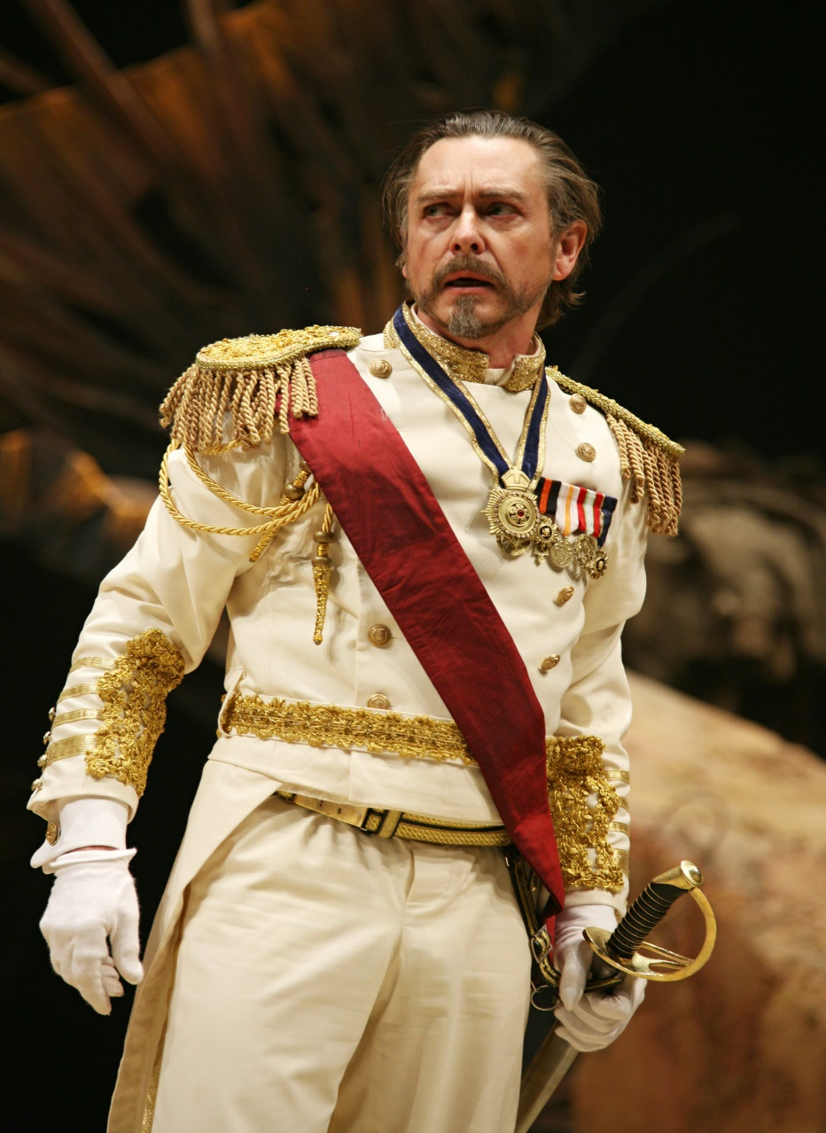

Alonso is the King of Naples. He helped Antonio to get rid of Prospero and take his brother’s place as Duke of Milan. He has two children, a daughter called Claribel and a son, Ferdinand. His fleet of ships is returning to Naples from Tunis but they are caught in a huge storm. Travelling with him is his son, his brother and other nobles. They are all washed up on the island after the storm, although Alonso thinks Ferdinand has drowned. When Alonso finally meets Prospero, he apologises and makes him Duke of Milan again. When he is reunited with Ferdinand and finds out about his engagement to Prospero’s daughter Miranda, he is delighted.
Facts we learn about Alonso at the start of the play:
- As King of Naples, he has the highest status of the nobles.
- He helped Antonio to take Prospero’s place.
- His ship is returning from Tunis where his daughter Claribel married the King of Tunis.
- He is very upset at loosing of his son Ferdinand, who he thinks has drowned.

Antonio is Prospero's younger brother. Prospero trusted him to help rule the dukedom of Milan? but Antonio used this trust against his brother and secretly plotted with Alonso to overthrow Prospero and have him and Miranda removed from the city. Antonio owes a debt to Alonso for his help and wants Sebastian to become King of Naples instead so that he can be released from that debt. He has very few lines in the last scene so it is not clear how he feels about seeing Prospero again.
Facts we learn about Antonio at the start of the play:
- Prospero trusted him to rule Milan while he was studying his magic books.
- Antonio has to give regular payments and support to Naples in return for Alonso's help in overthrowing Prospero.
- Antonio would prefer Sebastian to be King of Naples.

Gonzalo is chief advisor to Alonso, King of Naples. He is remembered by Prospero for his kindness in making sure that supplies, clothing and books were put aboard the boat when Prospero and Miranda were cast out to sea. He tries to keep Alonso positive as they search the island for Ferdinand and is aware that Sebastian and Antonio make fun of him.
Facts we learn about Gonzalo at the start of the play:
- When Prospero was cast out to sea, Gonzalo helped him by giving him food and drink as well as rich clothing and important magic books from his library.
- He is loyal to Alonso and tries to keep his spirits up as they search the island for Ferdinand.
- He is delighted that Ferdinand and Miranda will become king and queen.

