Rationing in the Second World War
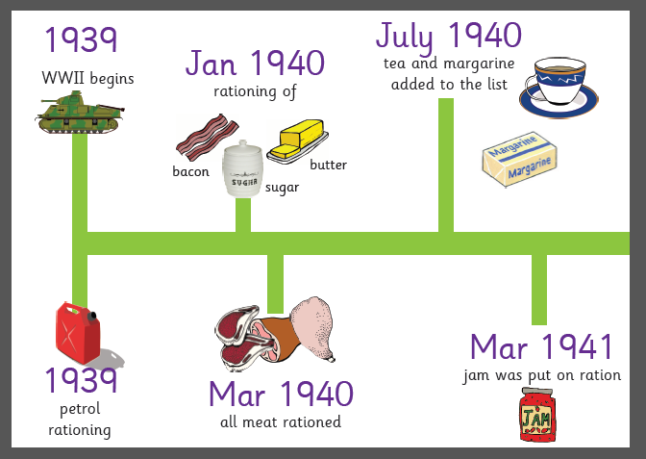
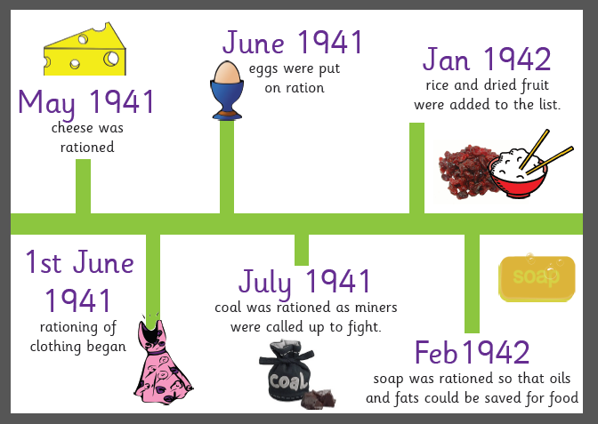
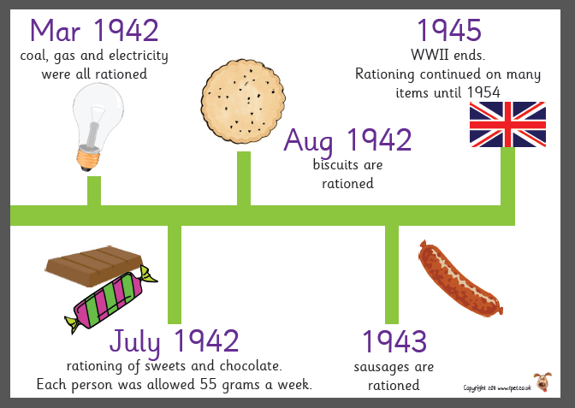
Why was rationing introduced?
To try and weaken the British, the Germans tried to cut off supplies of food and other goods. German submarines attacked many of the ships that brought food into Britain. This caused serious shortages of just about everything, and shopping became a daily nightmare.
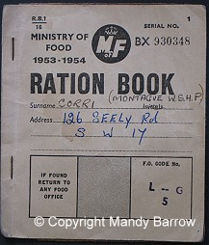
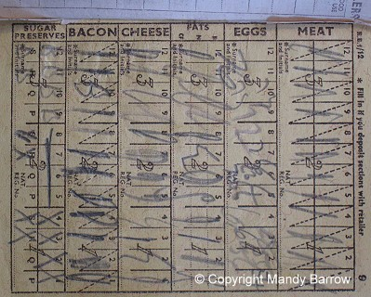
In January 1940, the British government introduced a strict system of food rationing to make certain that everybody got their fair share of foods that were scarce. Every man, woman and child was given a ration book with coupons inside. These were required before rationed goods could be purchased. Priority allowances of milk and eggs were given to those most in need, including children and expectant mothers.
As shortages increased, long queues became commonplace. It was common for someone to reach the front of a long queue, only to find out that the items they have been waiting for had run out.
Were all foods rationed?
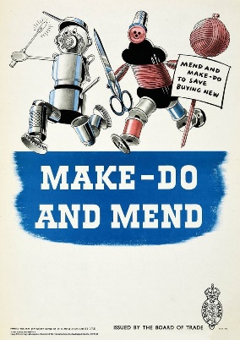
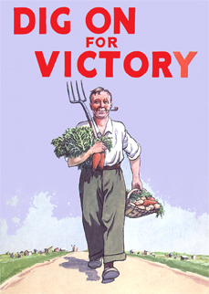
Not all foods were rationed. Fruit and vegetables were never rationed but were often in short supply, especially tomatoes, onions and fruit shipped from overseas. The government encouraged people to grow vegetables in their own gardens and allotments. Many public parks were also used for this purpose. The scheme became better known as ‘Dig for Victory’.
Was it just food that was rationed?
Clothing too was in short supply and rationed, so that ‘make do and mend’ became the new slogan. Pillowcases were made into baby clothes, and a father’s old trousers might become a skirt for his daughter. Old parachutes were made into blouses and nightdresses.

