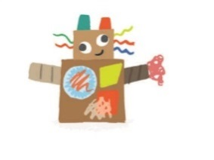**Character Parts Sheet**

***“Reading builds character”***

|  |  |
| --- | --- |
| A white circle with a black background  Description automatically generated with medium confidenceImage result for monster mouth cartoonImage result for monster nose cartoonImage result for eyes cartoon freeA picture containing light, dark  Description automatically generatedA picture containing light, dark  Description automatically generatedA picture containing text, clipart, wheel, gear  Description automatically generatedA picture containing text, clipart, wheel, gear  Description automatically generatedImage result for monster eyescartoon**Funny Faces -** Choose 1 face piece from this section for each of your first 5 challnges **OR** draw your own. | Image result for legscartoonImage result for legscartoonImage result for monster arms cartoonIcon  Description automatically generatedIcon  Description automatically generatedImage result for monster arms cartoonImage result for legs red cartoonImage result for funny ears cartoonImage result for funny ears cartoon**Body Bits -** Choose 1 piece from this sheet for each of your 6-10 challenges **OR** draw your own. |
| Image result for flower cartoon outlineImage result for outline moustache cartoonImage result for cartoon hatImage result for glasses cartoonImage result for cartoon hat**Awesome Accessories –** Choose another Funny Face, Body Bit or Awesome Accessory for every challenge completed above 10 **OR** add your own accessory, e.g. scarf, dress. | Cut out this label and take a photo of your finished character with it:  **My character’s name is:**  **The title of my character’s book would be:**  **Character description:**  **By: Year:** |