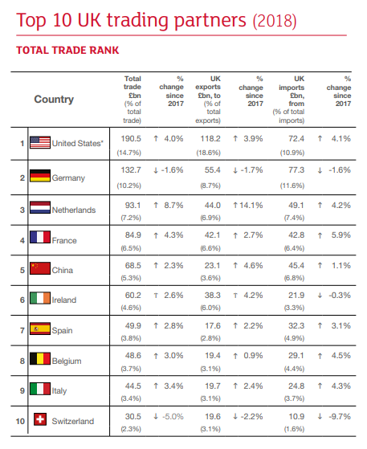
Source: Office for National Statistics UK Trade (January to March 2019)

