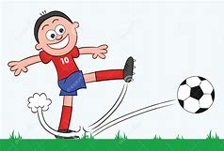 | What force is the boy using as he kicks the ball? Draw an arrow to show the direction of the force.
 | What force are the people using as they fall down from the sky? Draw an arrow to show the direction of force.
 | What force is being used as the person puts the fork into the ground? Draw an arrow to show the direction of force.
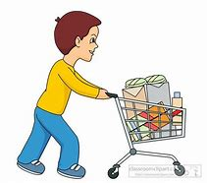 | What force is being used as they walk with the trolly? Draw an arrow to show the direction of force.
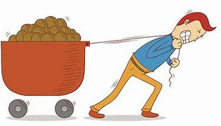 | What force is the person using in this image? Draw an arrow to show the direction of force.

