Here are some fun challenges for you to complete over February half term!
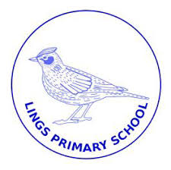
Lings’ Lockdown Bingo 2021
Complete the challenges in any order that you want and colour in the box to show it has been completed. Make sure you return the completed bingo sheet to your teacher by e-mail, through the blog or when we return to school.
Bake something delicious. | Create a piece of art using only 2 colours. | Make a list of all of the things that you are good at.
Have a family DVD night. | Send a secret note of kindness to someone in your family. | Make a den or a fort and curl up inside with a good book.
Go on a walk and make a list of all of the wildlife that you see. | Create a self-portrait using rice or pasta. | Play a board game with your family.
Help someone make dinner for your family. | Learn a new skill. | Make a picture from things you can find outside.
Create an obstacle course in your garden for the whole family to try. | Count all the different car colours that you can see outside your window. Maybe you could make a graph. | Perform an act of kindness. Maybe you could ask someone if they need help with something.

Good luck and we hope you have a great half term!
From all the staff at Lings.

