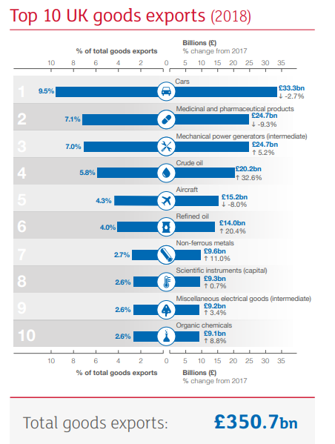

Source: Office for National Statistics UK Trade (July 2019)

