What is a Fairy?

Did you know fairies come in all shapes and sizes and not all fairies are girls? How interesting!

Fairies are mystical, magical creatures that dwell in enchanted forests and magical lands. The fairies are led by King Oberon, a wise and powerful fairy and his wife, the elegant and beautiful Queen Titania.

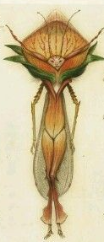

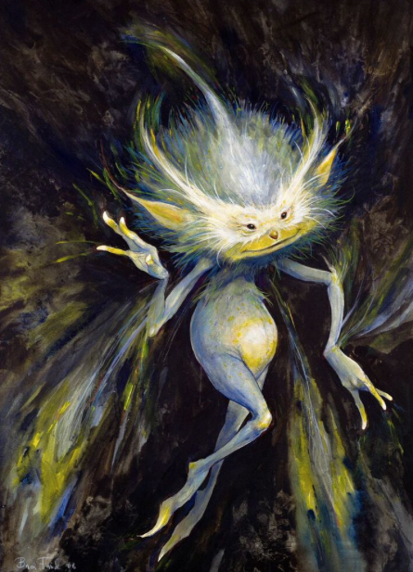 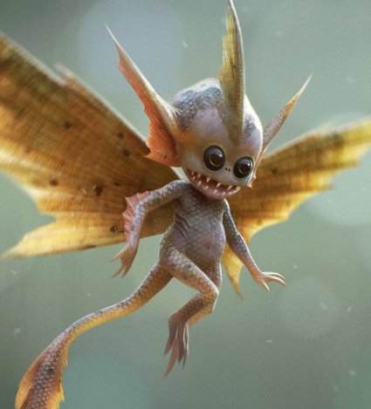 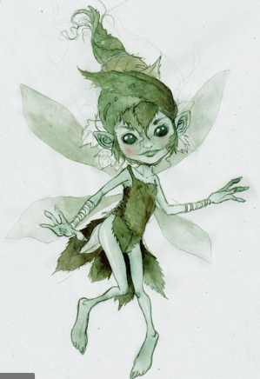

Fairies are often tiny creatures, filled with happiness and kindness but that isn’t true of all fairies. Some can be full of mischief and play magical tricks upon people. Most fairies hide away in their teeny homes when humans are around. If you look closely, you may find their homes hidden amongst the trees and ferns of a magical forest. Fairies like to wander through their magical forest looking to use their magical powers for good and sometimes bad.

*Over hill, over dale, Thorough bush, thorough brier, Over park, over pale, Thorough flood, thorough fire, I do wander everywhere.*

Many fairies have delicate wings, which they will use to fly swiftly through the bushes and skim over the fresh water streams. They will use their wands to create potions and magic amongst the beautiful flowers of the forests.

*I know a bank where the wild thyme blows, Where oxlips and the nodding violet grows.*

Many people think of fairies in sparkling, shimmery dresses with long golden hair, but not all fairies are pretty creatures. Some fairies can be strange looking and even a little ugly but they are just as powerful.