The Magical Flower.

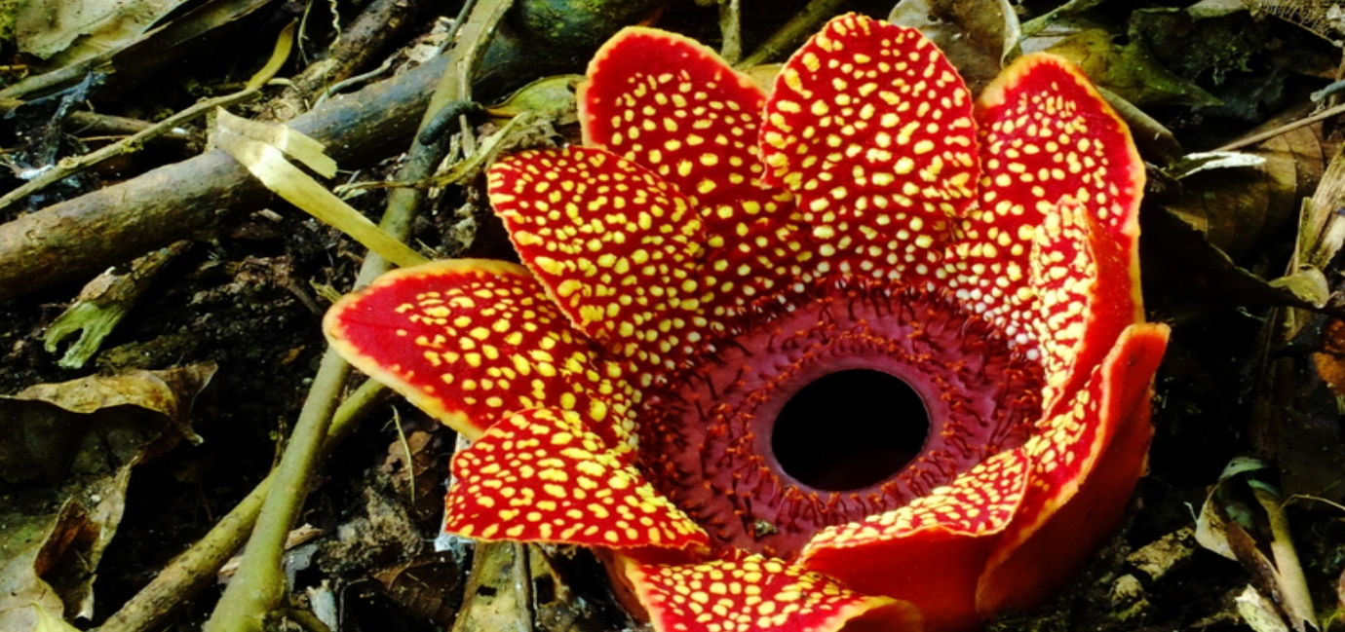

Deep in the woods, hidden between the leafy, green bushes and ferns grows a mysterious flower. It is not the most beautiful flower in the forest but it does have a special secret. This flower has a magical power that can be used by fairies.
The mystical flower grows down on the ground and does not have a long stem. It is surrounded by yellow and brown crunchy leaves. If you touch the flower it gives of an unpleasant smell of rotten fruit so that people won’t want to pick it. The flower is surrounded by giant, red petals covered in squishy yellow spots. During the night, these petals close, but in the sunshine they open revealing its unusual centre. In the middle of the petals, there is a red, soft part covered in sharp, tiny spikes that help to protect the flowers secret.
Right in the centre is a dark, gloomy hole leading inside the flower and this is where the magical part of the flower is hidden. Only the fairies know how to use the magical part of the flower and they will not share their secret in case the magic is used for harm.

