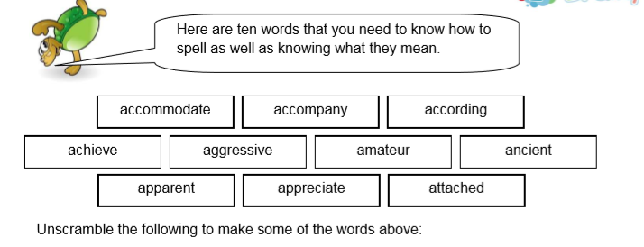
- hive ace ________________________ 3. sir egg vase _________________________

- cite a paper _____________________ 4. aced that ____________________________

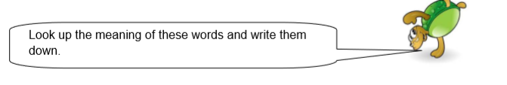
- accommodate ______________________________________________________

- accompany _______________________________________________________

- apparent __________________________________________________________




