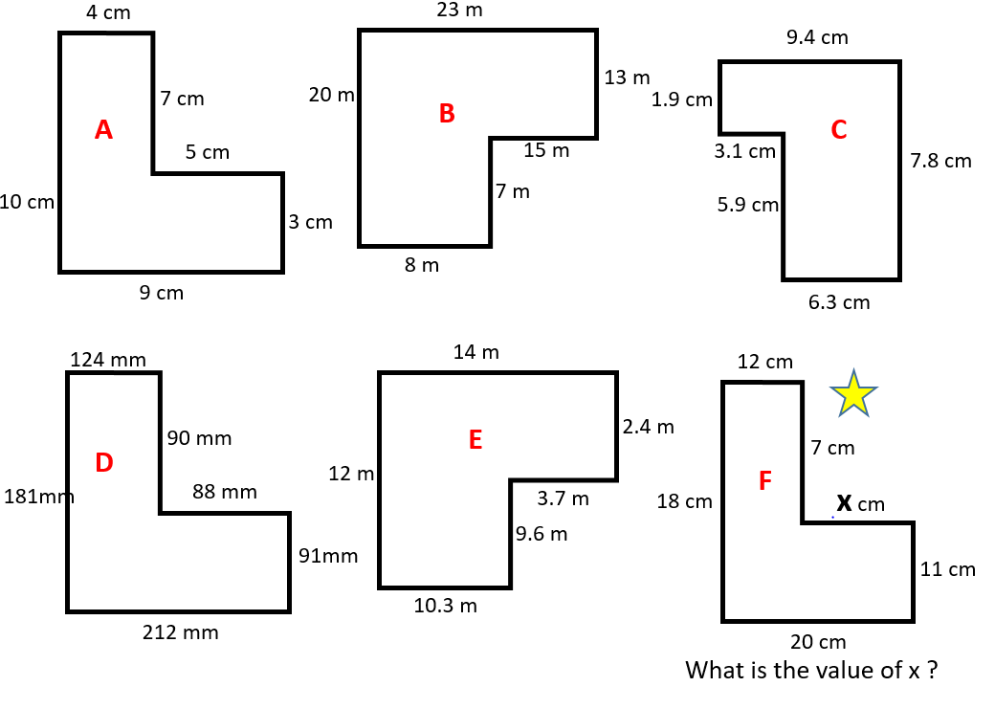
Hint for F:
Look at the opposite side which is 20cm.
12 cm has already been used so what is left for X?

