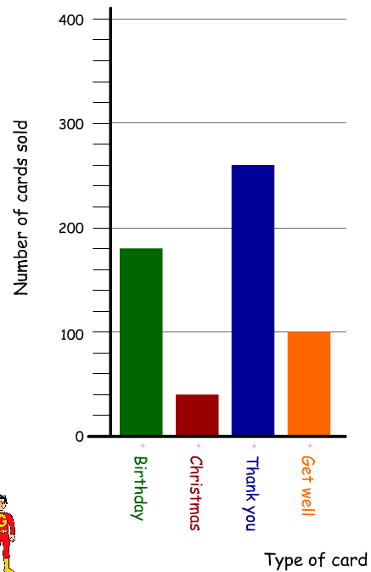 | - How many Birthday cards were sold?  - How many Thank You cards were sold?  - How many fewer Christmas cards were sold than Birthday cards?  - How many more Thank You cards were sold than Get Well cards?  - Which type of card is the mode?  - How many cards were sold altogether?
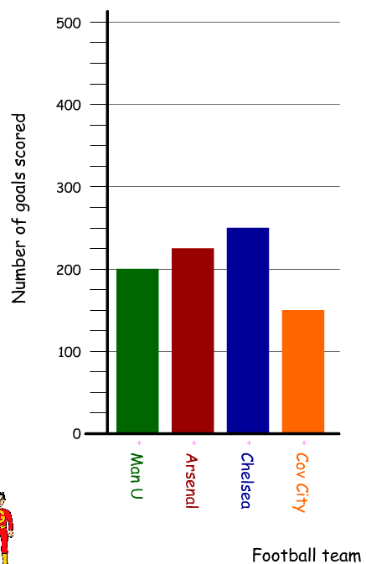 | - Which team scored the most goals?  - Which team scored the least goals?  - How many goals were scored by Chelsea?  - How many more goals did Chelsea score than Man U?  - How many goals were scored by Cov City and Arsenal?  - How many goals were scored altogether?

