

King Oberon told us “I am going to use the magical powers of this flower to restore peace and harmony. If the juice of this flower is dropped onto the eyes of a person, they will become calm and full of love.”

King Oberon said he is ready should the humans return, to use this powerful flower that only his fairies know how to get the juice from. He has ordered his fairies to seek out the flower, prepare the potion and he checks with them to see if they have completed his orders to use the juice on the humans.

*“Thou yet latched the Athenian’s eyes with the love-juice, as I did bid thee do?”*

Will this prevent the humans from arguing again? Will this stop the peace and calmness of the enchanted forest being shattered again?

Is the magic flower the way to stop this problem?

Deep in the forest outside of the city of Athens, a mysterious flower has been found growing on the ground.

The enchanted forest is usually a beautiful and peaceful place, but recently this peace was destroyed when human entered the woods and started arguing loudly.

The handsome and wise King Oberon and his wife, the charming Titania were reported to be furious that their kingdom had been disturbed.

Today however, a solution was found! reported, the sounds of shouting and arguing have echoed between the tall trees.

[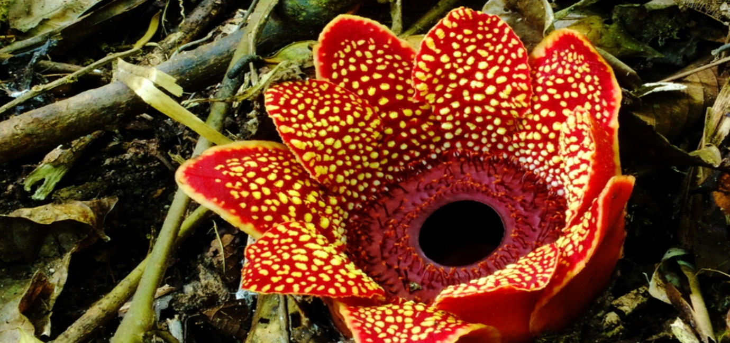](https://www.google.com/url?sa=i&url=https://www.britannica.com/video/195984/species-plants&psig=AOvVaw1ENj6qDgQMAMaifZm-1dl9&ust=1611235034810000&source=images&cd=vfe&ved=0CAIQjRxqFwoTCJCDp7HMqu4CFQAAAAAdAAAAABAZ)

The magical flower found in the forest.

BREAKING NEWS!

Magical Flower Discovered To Restore Calm !

The Daily News