**Design-a-Fairy!**

You are a top UK film director currently filming for a movie production of A Midsummer Night’s Dream. It is your job to brief the costume designer as to how you want your characters to look and dress. Your task is to write a brief to your designer giving clear instructions as to how the fairies should be dressed and made up.

Below is a template for your brief, follow this to ensure your costume designer understands your ideas.

**Overall design concept**

* 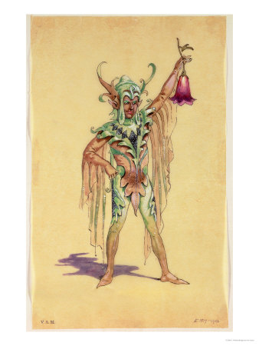*I want Puck to look as though he is from another world. He should appear goblin-like and mischievous......*

**Costume**

* *Puck’s costume should be made from a light and floaty material e.g. thin cotton*
* *The costume is very colourful and bright*
* *The arms are covered, with long draping material*

**Makeup**

* *Much of Puck’s face will be covered, but the area exposed should be green.*

**Finally, once you have completed your costume design you need to brief your actor on how to play Puck.**

**Actor performance brief**

*The fairy should be played with a sense of mystery, as though he is from another world. I would want my fairy to move swiftly across the set, with small but deliberate moves. He should speak in a high pitched and sometimes quiet voice..................................*