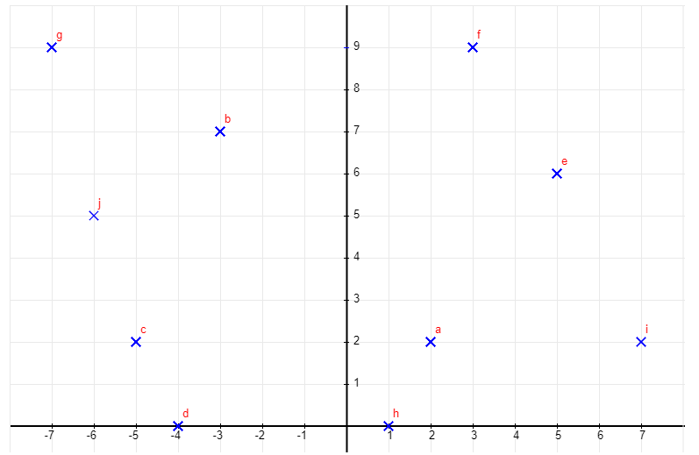
Find the coordinates of the following points:
a = f =
b = g =
c = h =
d = I =
e = j =

