Unit 12: Angles and properties of shapes, Lesson 3

Think together

**1** Find out if each angle is greater than, equal to or less than a right angle.

1. C E



70°

90°

90°

1. D F



120°

150°

25°

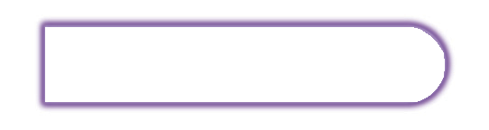

**106**



In maths, **acute** means less than a right angle, and **obtuse** means greater than a right angle.

© Pearson Education Ltd 2018

Compare each angle with a right angle.



**2**



1. C E



1. D F

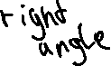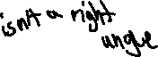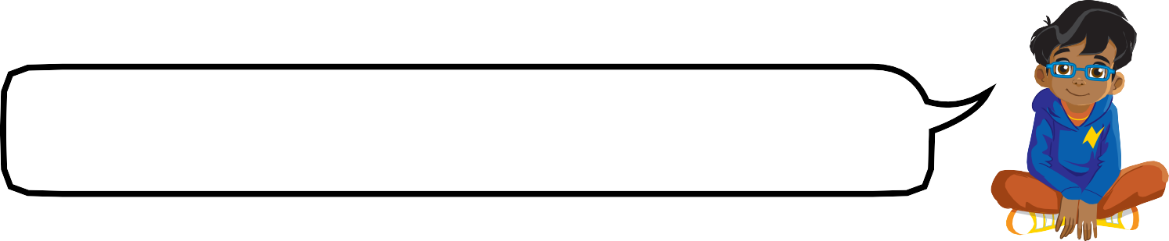

I know the angle between 12 and 3 is a right angle. I wonder which other pairs of numbers make a right angle.

**3** Isla has made some angles. She wants to make some different acute and obtuse angles. How many different acute and obtuse angles can Isla make?

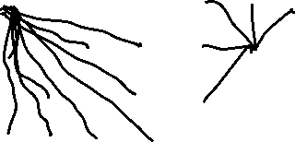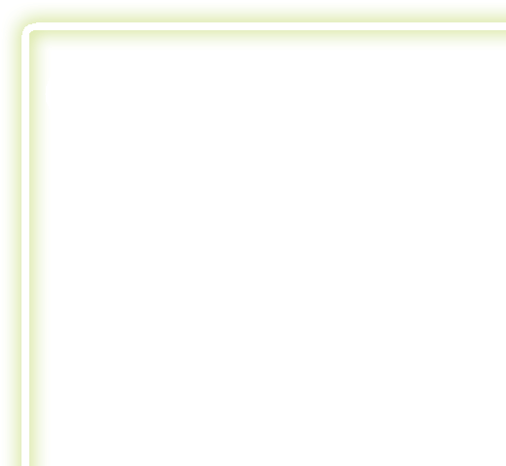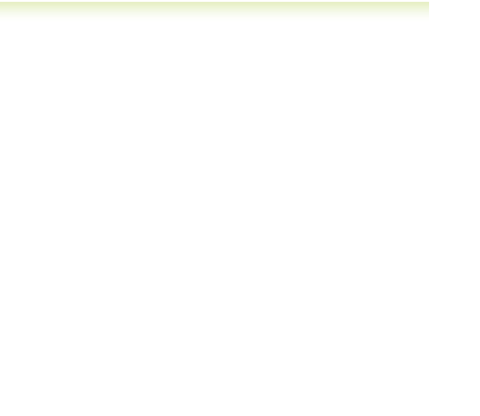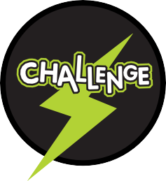

Unit 12: Angles and properties of shapes, Lesson 3

© Pearson Education Ltd 2018

➜ **Practice book p77**

**107**