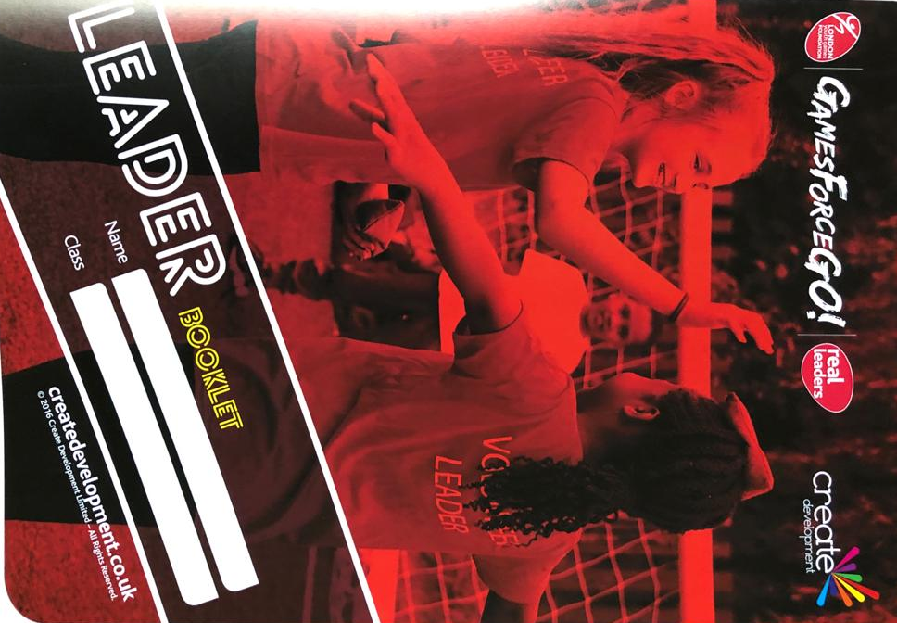
Lings Primary School Young Leaders Application
Name
Year Group
House
Why do you want to be a young leader?

What is the role of a young leader at Lings Primary School?

Task 1: Here is a young leader. Can you write the skills and qualities of a young leader around the picture. You can draw pictures to show how a leader can show these qualities. For example: good timekeeping skills can be shown by drawing a watch.

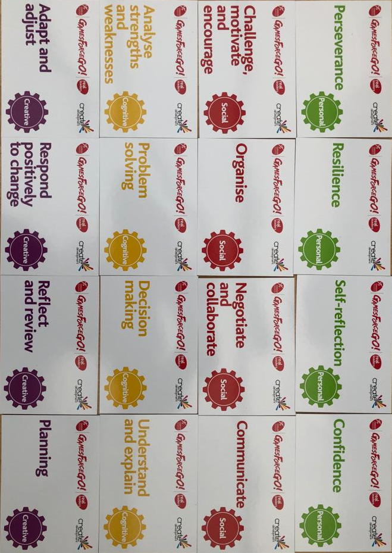
Task 2: Below is a list of skills that you will develop throughout the young leader training programme. Can you please put these skills in a pyramid, with the most important at the top and the least important at the bottom. You can have as many or as few on each level. There is no right answer as it is your opinion.

Most important

Least Important
Task 3: Your final task is to create a new playground game, using equipment and space we would have available at school. You will need to:
- Choose a name for your game
- List your equipment
- Explain how to play the game
- List the rules of your game
- Tell us ways you can make the game easier and harder
Name of the Game
Equipment List/ Space Needed
How to play the game?/ Rules of the Game
How can you make the game easier? | How can you make the game harder?

