Layers of the Ocean
Oceans cover two-thirds of our Earth. There are five main oceans which all flow into each other:
the Arctic Ocean, the Atlantic Ocean, the Indian
Irish

North Sea

Ocean, the Pacific Ocean and the Southern or Antarctic Ocean.

What Are the Layers of the Ocean?
Oceans are made of five layers or depths. Each layer has different characteristics, such as the temperature and the amount of light. They have unique creatures living within them.
Sea

English Channel

Atlantic Ocean

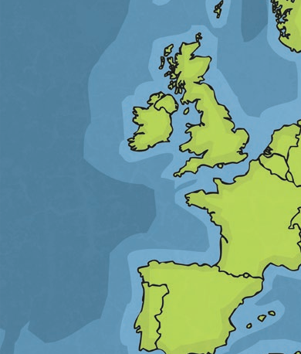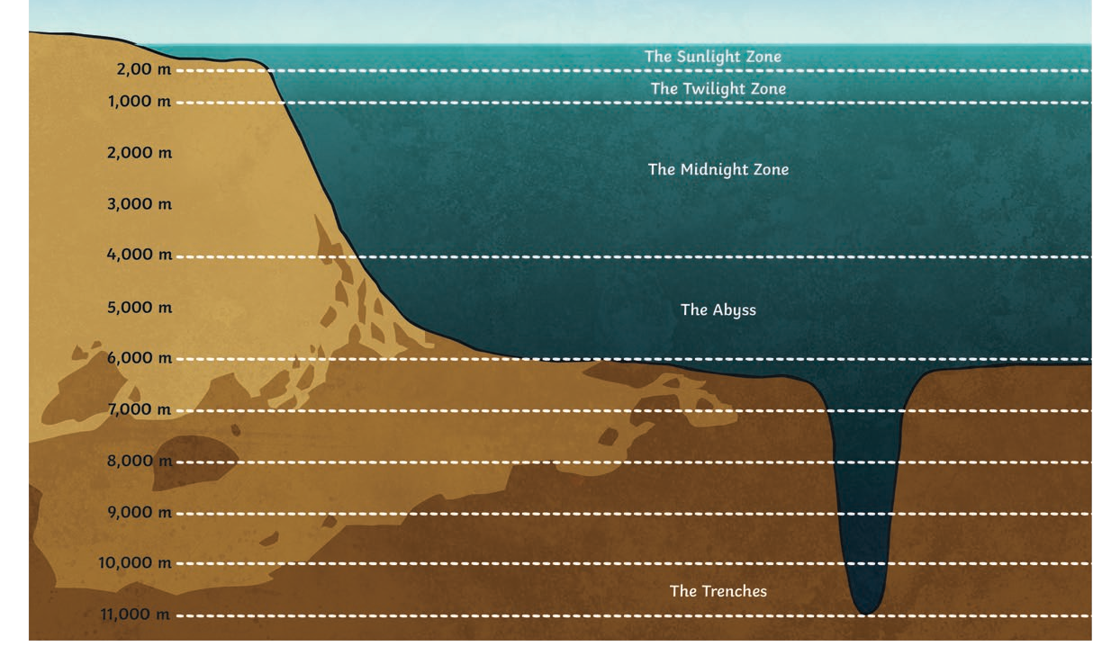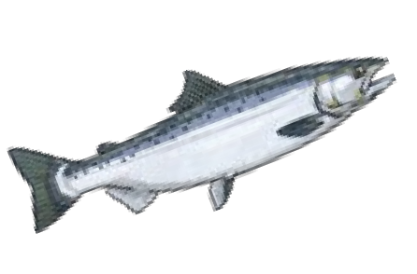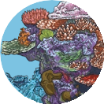

The Sunlight Zone – up to 200m below the surface of the ocean

There is plenty of sunlight and heat in this zone although both decrease as you go deeper. There are many different living things within this layer, including:

seaweed dolphins fish coral reefs
Humans enjoy this warm layer for activities such as swimming and fishing.

Layers of the Ocean
The Twilight Zone – up to 1,000m below the surface of the ocean

Only faint sunrays reach this deeper layer. No plants grow within this layer. It is home to sea animals which often have large eyes, including:

- the sea cucumber;
- the swordfish;
- the wolf eel;
- the octopus.

Humans can dive to this layer wearing protective suits.

The Midnight Zone – up to 4,000m below the surface of the ocean

The Midnight Zone is pitch-black because sunlight cannot reach this layer. Some light can be seen from creatures that make their own light, such as:

  - anglerfish;
  - viperfish;
  - jellyfish.

Some creatures, such as the sperm whale, dive to these depths to hunt for food.
Abyss – up to 6,000m below the surface of the ocean
The sunlight cannot reach this layer at all so it is pitch-black and near freezing. Very few creatures live here but those that do are mainly transparent, blind invertebrates, such as:

  - lanternfish;
  - amphipod;
  - squid

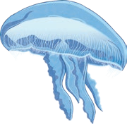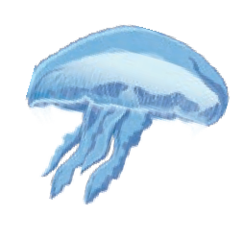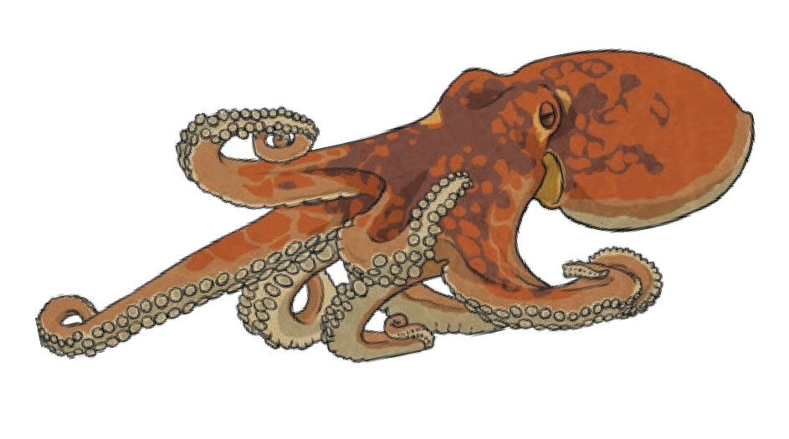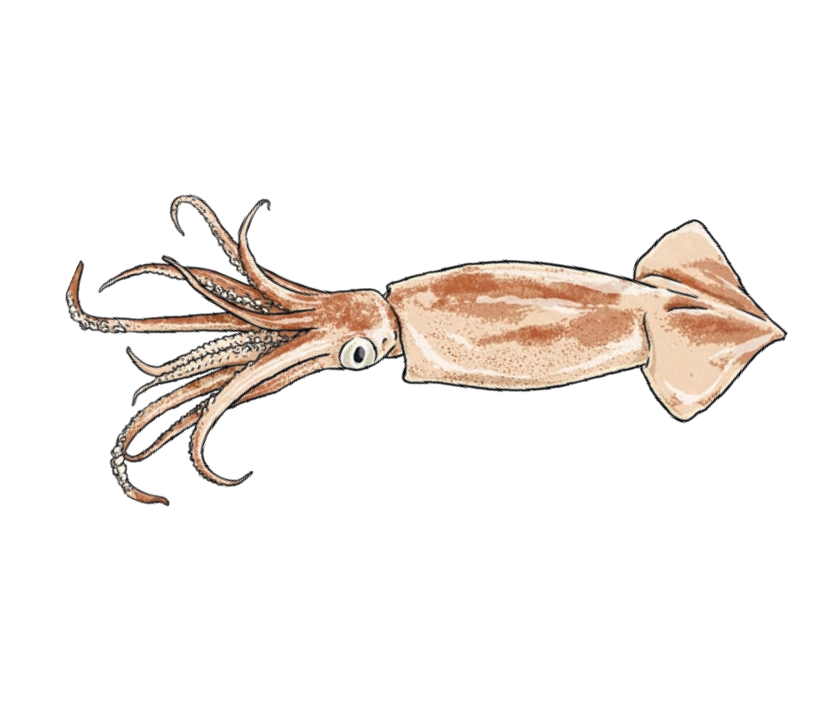

The Trenches – up to 11,000m below the surface of the ocean
The Trenches are narrow, underwater valleys of the ocean floor which have high pressure and near-freezing temperatures. There is no natural light in this zone but different creatures can be found, such as sea stars.

Did You Know…?
The deepest part of the ocean ever to be explored by humans is the Mariana
Trench. It is almost 11,000m deep! Specialist scientific equipment had to be used.

Questions
- How much of the Earth do oceans cover? Tick one. one-third
two-thirds
three-quarters half

- Match each layer of the ocean to its depth below the surface.

Sunlight Zone

up to 11,000m

Midnight Zone

up to 4,000m

The Trenches

up to 200m

- In the Sunlight Zone, what do humans enjoy doing? Tick two.
diving fishing
swimming warming up

- Which of these is not a creature you might find in the Abyss? Tick one.
sperm whale sea stars
amphipod squid

- Fill in the missing words in this sentence

The Trenches are narrow, underwater of the ocean floor which have
high and near temperatures.

- Give two examples of creatures found in the Midnight Zone.
1.
2.

- Which layer would you most like to visit? Give two reasons.

I would like to visit the sunlight zone as I would lone to see the great barrier reef and see the amazing creatures

Answers
- How much of the Earth do oceans cover? Tick one. one-third

two-thirds
three-quarters half

- Match each layer of the ocean to its depth below the surface.
Sunlight Zone
The Trenches

up to 4,000m

Midnight Zone

up to 200m

up to 11,000m

- In the Sunlight Zone, what do humans enjoy doing? Tick two.
diving
fishing
swimming
warming up

- Which of these is not a creature you might find in the Abyss? Tick one.
sperm whale
sea stars amphipod squid

- Fill in the missing words in this sentence:
The Trenches are narrow, underwater valleys of the ocean floor which have
high pressure and near freezing temperatures.

- Give two examples of creatures found in the Midnight Zone.

Accept any two of the following: anglerfish; viperfish; jellyfish.

- Which layer would you most like to visit? Give two reasons.

Pupils’ own responses, such as: I would most like to visit the Midnight Zone because I’d like to see the interesting creatures that make their own light and I think it would be fun to explore the ocean in the dark.

Layers of the Ocean

Oceans cover two-thirds of our Earth and there are five main oceans which all flow into each other: the Arctic Ocean, the Atlantic Ocean, the Indian Ocean, the Pacific Ocean and the Southern or Antarctic Ocean.
What Are the Layers of the Ocean?
Oceans are made of five layers, or depths, which all have different characteristics, such as temperature and amount of light. They have unique creatures living within them.

The Sunlight Zone

Irish Sea

English Channel

Atlantic Ocean

North Sea

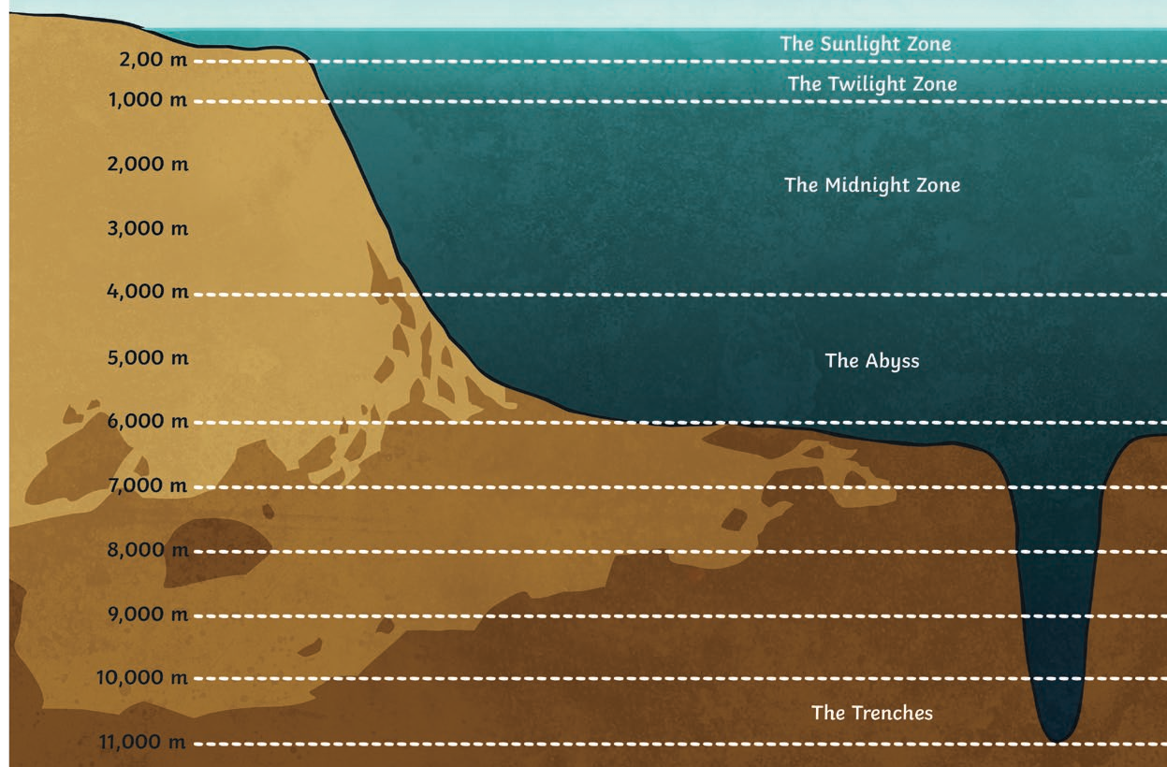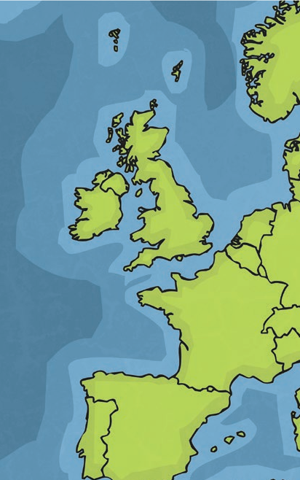
The Sunlight Zone is up to 200m below the surface of the ocean and there is plenty of sunlight and heat in this zone although these both decrease as you go deeper. There are many different living things within this layer, including seaweed, dolphins, fish and coral reefs. Humans enjoy this warm layer for activities such as swimming and fishing.

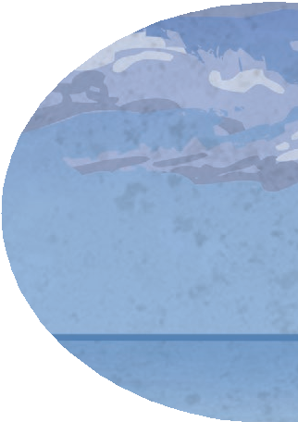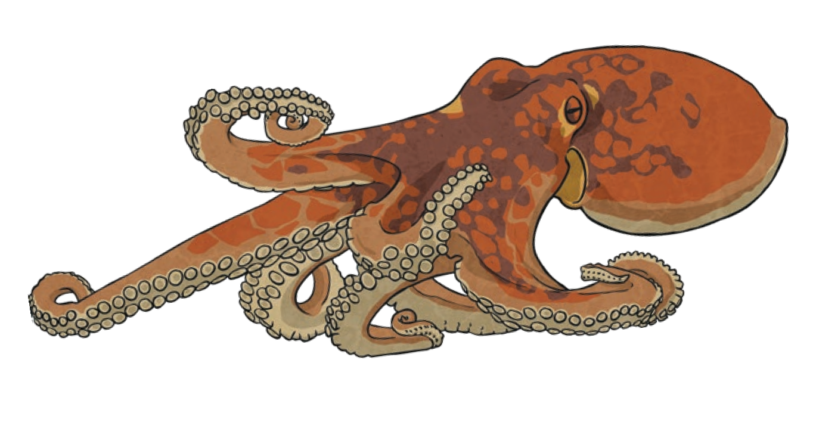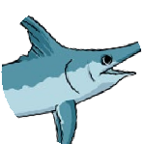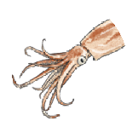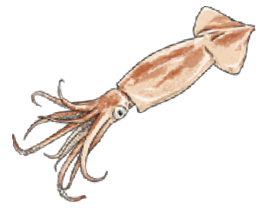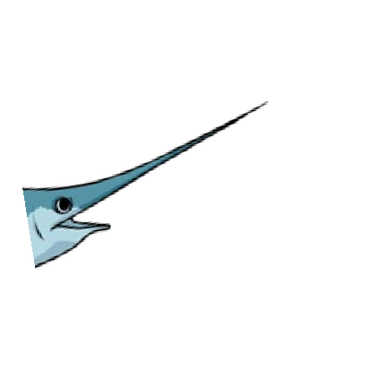Layers of the Ocean

The Twilight Zone

The Twilight Zone is up to 1,000m below the surface of the ocean and only faint sunrays reach this layer, making it very cold.
It is home to unique sea animals, which often have large eyes to help them to see, such as the sea cucumber, the swordfish, the wolf eel and the octopus. No plants grow within this layer and humans can only
dive to this layer wearing protective suits.

The Midnight Zone
The Midnight Zone

The Midnight Zone is up to 4,000m below the surface of the ocean and it is pitch-black because sunlight cannot reach this far down. Some light can be seen from the creatures that make their own light, such as anglerfish, viperfish and jellyfish. Some creatures, such as the sperm whale, dive to these depths to hunt for food.

Abyss

The Abyss is up to 6,000m below the surface of the ocean so sunlight cannot reach this layer at all. It is pitch-black and near freezing meaning very few creatures live here. Those that do are mainly transparent, blind invertebrates, such as lanternfish, amphipods and squid.
The Trenches
The ocean floor is made up of narrow, underwater trenches. These trenches are up to 11,000m below the surface within the ocean floor. The temperature is near freezing and there is extreme pressure. No natural light exists in this zone but different creatures can be found, such as sea stars.

Did You Know…?
The deepest part of the ocean ever to be explored by humans, using specialist
scientific equipment, is the Mariana Trench. It is almost 11,000m deep!

Questions
- How many main oceans are there? Tick one. two
three four five

- Number these ocean layers in order of how deep they are, with 1 being closest to the surface.

The Midnight Zone The Sunlight Zone The Trenches
The Abyss

The Twilight Zone

- Which facts are true about the Sunlight Zone? Tick two.
It is up to 1,000m below the surface of the ocean.
There is plenty of heat.
Humans enjoy this layer for swimming. There are very few creatures living here.
- Which layer can humans explore wearing a protective suit? Tick one. The Sunlight Zone
The Twilight Zone The Midnight Zone The Abyss

- Find and copy a phrase which shows that the Abyss is very dark.

- What is the name of the deepest part of the ocean explored by humans?

- Why do some of the creatures in the Midnight Zone make their own light?

- Why is specialist scientific equipment needed to explore the trenches?

Answers
- How many main oceans are there? Tick one. two
three four five

- Number these ocean layers in order of how deep they are, with 1 being closest to the surface.

The Midnight Zone The Sunlight Zone The Trenches
3
1
5
4
The Abyss

The Twilight Zone
2

- Which facts are true about the Sunlight Zone? Tick two.
It is up to 1,000m below the surface of the ocean.

There is plenty of heat.
Humans enjoy this layer for swimming.
There are very few creatures living here.
- Which layer can humans explore wearing a protective suit? Tick one. The Sunlight Zone
The Twilight Zone The Midnight Zone The Abyss

- Find and copy a phrase which shows that the Abyss is very dark.

pitch-black

- What is the name of the deepest part of the ocean explored by humans?

The name of the deepest part of the ocean explored by humans is the Mariana Trench.

- Why do some of the creatures in the Midnight Zone make their own light?

Pupils’ own responses, such as: Because it is so dark in the Midnight Zone, some
creatures make their own light so that they can find food to eat.

- Why is specialist scientific equipment needed to explore the trenches?

Pupils’ own responses, such as: It is very cold with high pressure so humans would not be able to dive that deep without getting hurt – the specialist scientific equipment means they can explore the trenches safely.

Layers of the Ocean

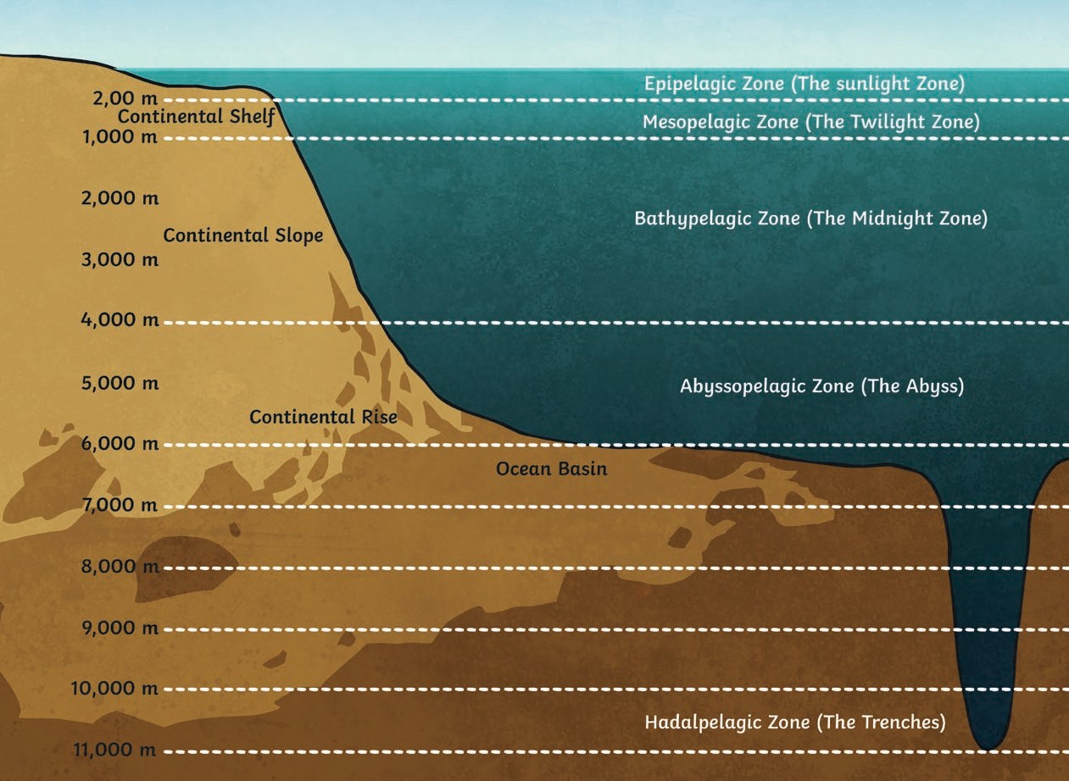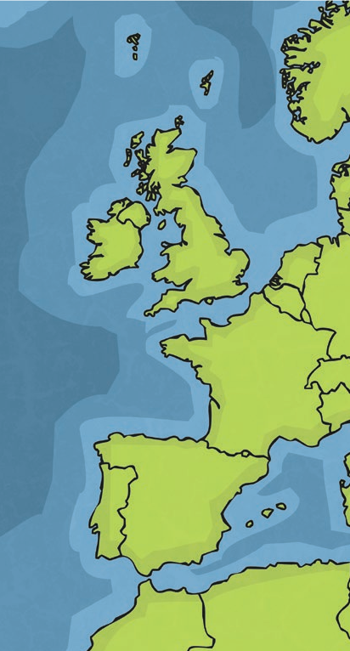

Irish Sea

English Channel

Atlantic Ocean

North Sea
Oceans cover two-thirds of our Earth and there are five oceans (the Pacific Ocean, the Atlantic Ocean, the Indian Ocean, the Antarctic or Southern Ocean and the Arctic Ocean) that all flow into each other.
Did You Know...?
The Pacific Ocean is the largest and deepest of all the oceans. It is so deep in places that the world’s tallest mountain, Everest, would sink without a trace!

What Are the Layers of the Ocean?
Oceans are made of five layers which all have their own characteristics, including temperature, light and unique creatures living within them.

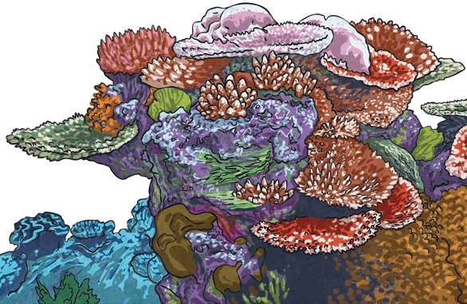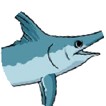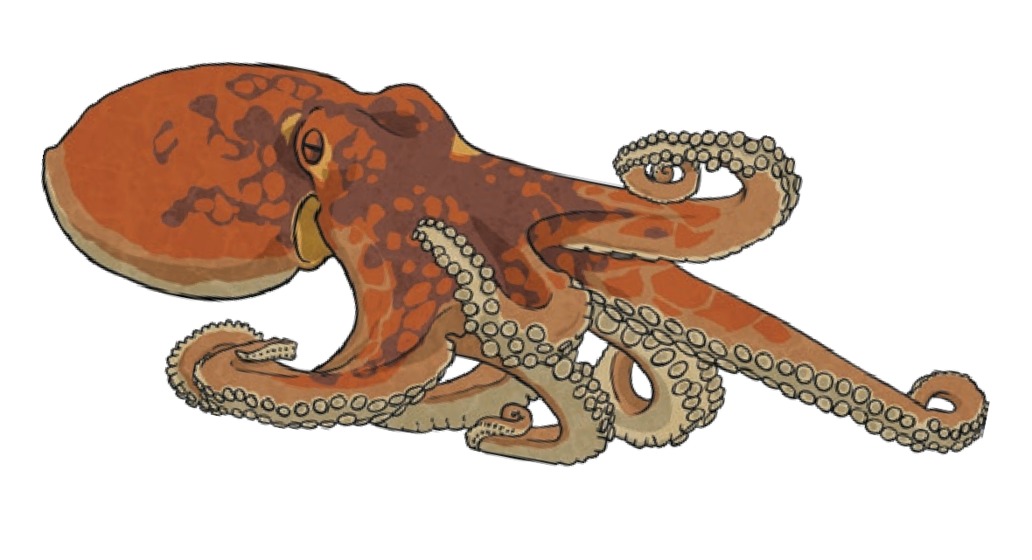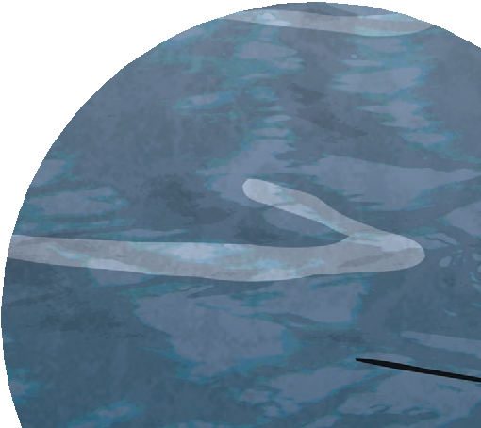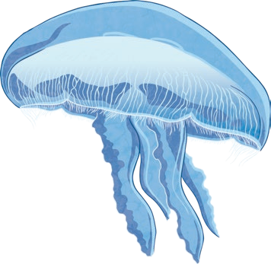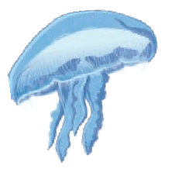Layers of the Ocean

Epipelagic Zone (Sunlight Zone)

The Epipelagic Zone is up to 200m below the surface of the ocean. Sunlight reaches it which means that there is plenty of light and heat in this zone although both decrease the deeper you go. Due to the light and
warmth, this is the layer with most life, including coral reefs, seaweed which plant feeders eat and fast swimming hunters, such as dolphins and salmon. Humans enjoy this layer for activities such as swimming and fishing.

Mesopelagic Zone (Twilight Zone)

Up to 1,000m below the surface of the ocean, the Mesopelagic Zone is cold because only faint sunrays reach it. This layer is home to some of the strangest
sea animals, which often have large eyes to help
them see, including the sea cucumber, swordfish, wolf eel and octopus. No plants grow within this layer so creatures either feed by filtering the water or hunting other creatures at speed. Humans can dive to this layer but they must wear protective suits.

Bathypelagic Zone (Midnight Zone)
The Midnight Zone

The Midnight Zone, which makes up nine-tenths of the ocean, is up to 4,000m below the surface of the ocean. It gets its name from the fact that sunlight cannot reach it. Some light, however, can be seen from some of the
plants and creatures, such as anglerfish, viperfish and jellyfish, that produce their own light (bioluminescent). They use this light to hunt their prey. Some larger creatures, such as the sperm whale, dive to these depths to hunt for food.

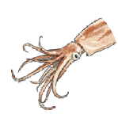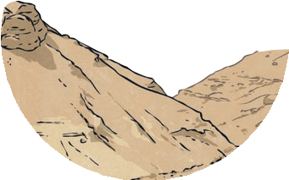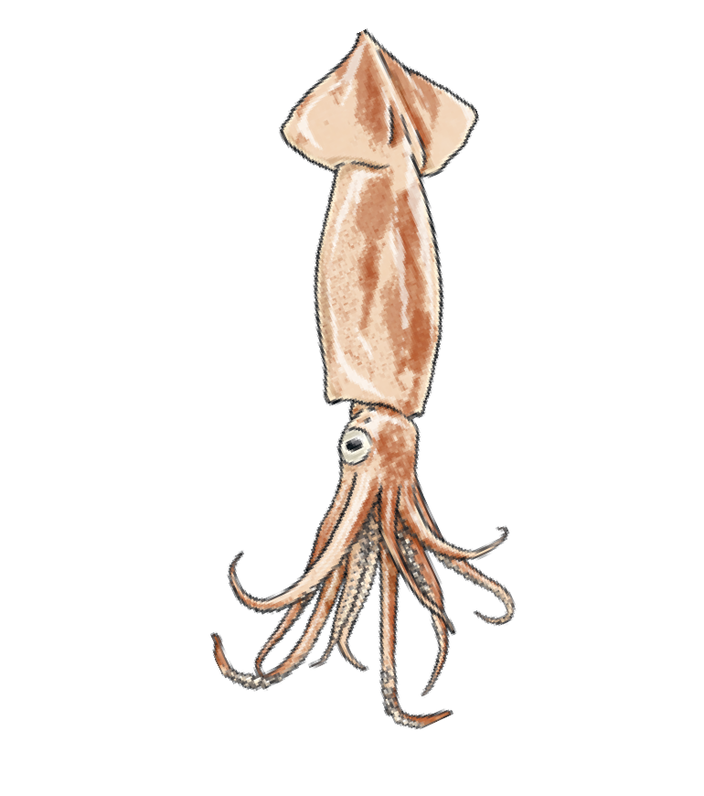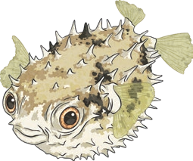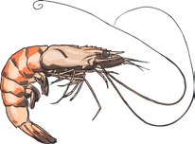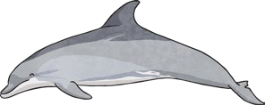Layers of the Ocean

Abyssopelagic Zone (Abyss)

This layer is up to 6,000m below the surface of the ocean and contains three-quarters of the ocean bed, which is covered with thick mud made from the remains of dead animals. No sunlight reaches this layer so it is pitch-black and near freezing, meaning that few creatures live here. Those that do are mainly transparent, blind invertebrates, such as lanternfish, amphipods and squid.
Hadalpelagic Zone (The Trenches)
The Trenches, 11,000m below the surface of the ocean, is actually a series of narrow valleys which can only be explored using specialist scientific equipment because of the immense pressure and near-freezing temperatures. No sunlight reaches this zone but unique creatures can be found, including some sea stars.

The ocean is a wonderful part of our world and oceanographers (people who study the plants and animals of the ocean) hope it will be explored more as technology advances.

Questions
- Which is the deepest ocean on Earth? Tick one. the Pacific Ocean
the Atlantic Ocean the Indian Ocean the Arctic Ocean

Oceans have unique creatures living within them.
What does the word unique mean? Tick one.
similar
individual many
few

- Name three creatures found in the Mesopelagic Zone.
1.
2.
3.

- Fill in the missing words in this sentence:
The Bathypelagic Zone, making up of the ocean, is up to
below the surface of the ocean and gets its name from the fact that
cannot reach this layer.

- Find and copy one word which tells you that many of the creatures found in the Abyssopelagic Zone are see-through.

- Why do you think that no plants grow in the Mesopelagic Zone?

Layers of the Ocean
- In your own words, explain what is meant by bioluminescent.

- Which layer would you least like to visit? Give two reasons.

Answers
- Which is the deepest ocean on Earth? Tick one.
the Pacific Ocean the Atlantic Ocean the Indian Ocean the Arctic Ocean

Oceans have unique creatures living within them.
What does the word unique mean? Tick one.
similar
individual
many few
- Name three creatures found in the Mesopelagic Zone.

Accept any three of the following: sea cucumber; swordfish; wolf eel; octopus.

- Fill in the missing words in this sentence:

The Bathypelagic Zone, making up nine-tenths of the ocean, is up to 4,000m below the surface of the ocean and gets its name from the fact that sunlight cannot reach this layer.
- Find and copy one word which tells you that many of the creatures found in the Abyssopelagic Zone are see-through.

transparent
- Why do you think that no plants grow in the Mesopelagic Zone?

Pupils’ own responses, such as: Only faint sunlight reaches this layer and plants need
sunlight to grow healthily.
- In your own words, explain what is meant by bioluminescent.

Pupils’ own responses, such as: Bioluminescent means plants and creatures that
produce their own light.
- Which layer would you least like to visit? Give two reasons.

Pupils’ own responses, such as: I would least like to visit the Abyss because it is pitch- black and I don’t like the dark. It is also covered in thick mud that is made from dead creatures which sounds slimy and horrible.
visit twinkl.com

