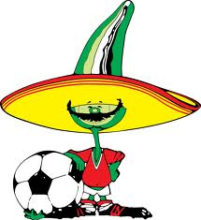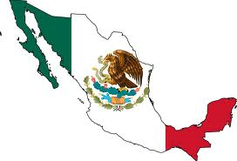

Hola, Me llamo Carmen. In MEKIKO, we speak Spanish. Today I will show you a little bit of MEKIKO, Si?

Come with me, por favor. To learn more Spanish , go to- <http://www.bbc.co.uk/languages/spanish/quickfix/basics.shtml>

BASIC MEXICAN FOOD Like any other culture, food is very important.

Here are some things you may be familiar with.

 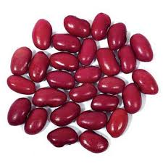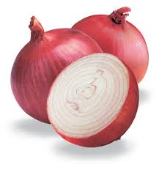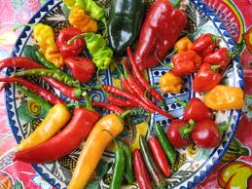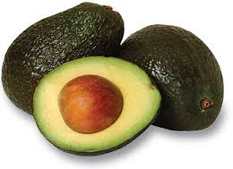

Do you know that in Mexico, we have MAGIC beans? Really! The famous Mexican jumping bean…

…. but why do they jump? ________________________________

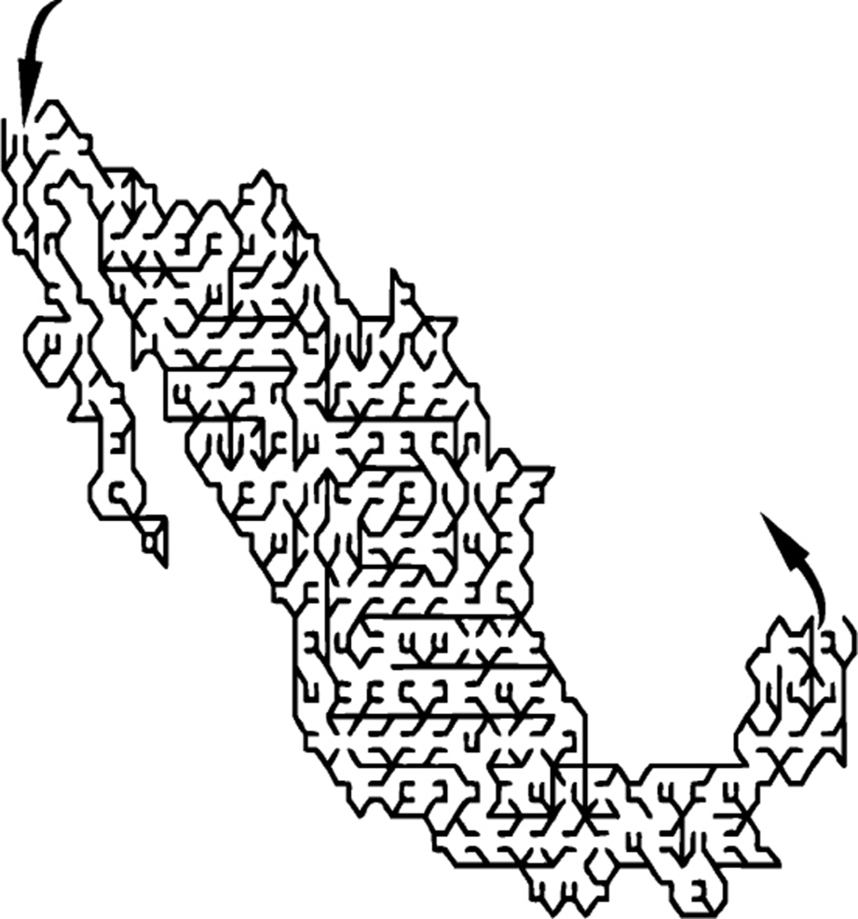

Hey amigo, do you want to make a sombrero? It’s really easy. This is what you need to get started.

1. Paint, scissors, hole punch, wool or string and beads!
2. Have fun!

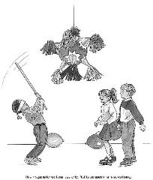

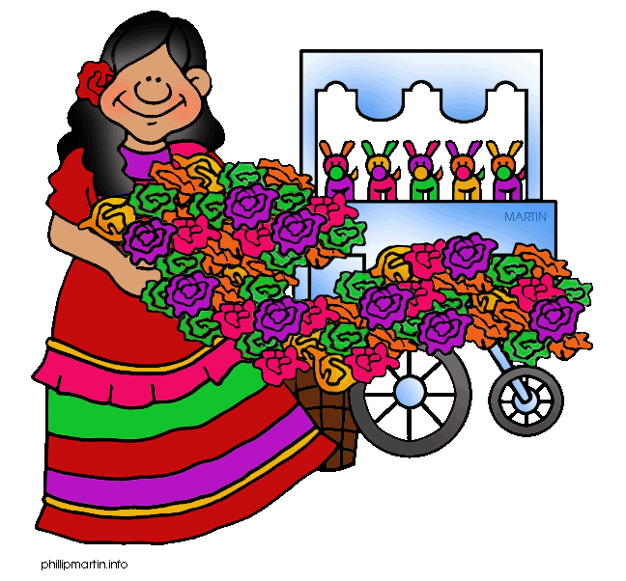

Balonmano (handball) is an ancient Mayan religious ceremony that has evolved into a game for children. At one time the ball represented the powerful Sun God, and whoever dropped the ball ________! We’ll play with balloons☺ …

P.S. No-one will die if they drop the balloon!

There's been a long tradition in Mexico of constructing things, such as flowers, out of colored tissue paper. It's a tradition that started more than 200 years ago and still growing. The piñata is a wonderful example of an exciting paper craft.

Read more: [The History of Mexican Tissue Flowers | eHow.com](http://www.ehow.com/about_5368006_history-mexican-tissue-flowers.html#ixzz1PHyitfW9) <http://www.ehow.com/about_5368006_history-mexican-tissue-flowers.html#ixzz1PHyitfW9>

We will now visit one of the seven wonders of the ancient world.

# Something you should know. ’Chichen- Itza (chee-cha nee-sa) was used as a temple and means, “At the mouth of the well of the Itza." This is where people were __________________to the gods! The large steps end in two big serpent (snake) heads. Color the feathered serpent gods below.

Take a picture of Chichen-Itza and paste it here.

Chichen-Itza, Yucatán, Mexico

Mexico is also famous for fossils! Do you want to go on a dig?

Let’s see if we can find some dinosaur bones. <http://channel.nationalgeographic.com/channel/dinosaurs/flash/fossil-hunt-game.html>

