Monster Line-Up

The pupils in Class 3 at Monster High are all different heights. Cut out each monster. Draw a number line and put each monster in the appropriate place on your number line.

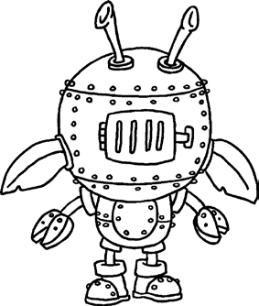  1.1m | 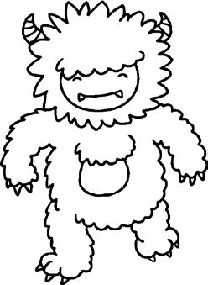  2.1m | 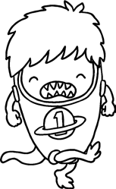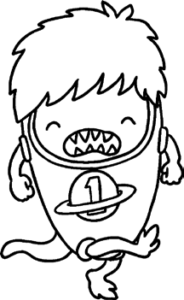  1.8m | 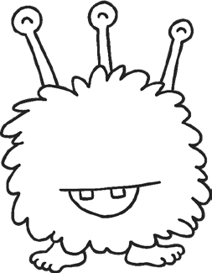  0.9m | 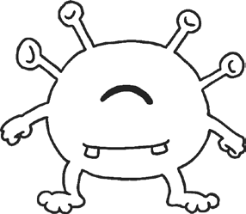  0.6m | 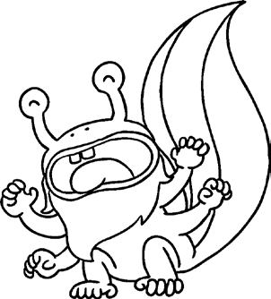  1.6m
Complete the statements by writing < or > in each box.

0.6m
1.1m
1.1m
0.9m
1.8m
0.6m

2.1m
1.8m
1.6m
2.1m
0.9m
1.6m

Class 4 at Monster High have measured themselves more accurately. Cut out each monster and draw another number line to place these monsters on.

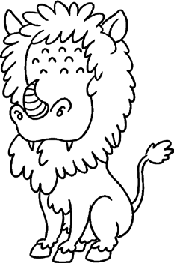  1.32m | 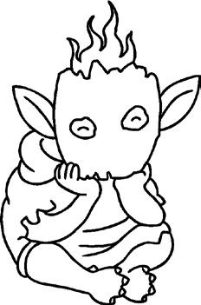  1.05m | 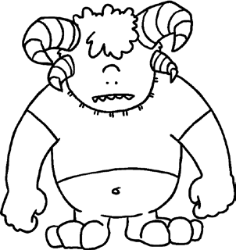  1.97m | 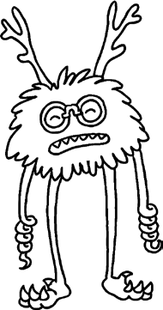  1.50m | 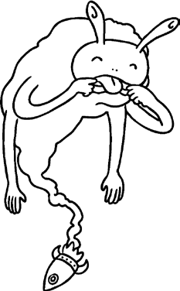  1.76m | 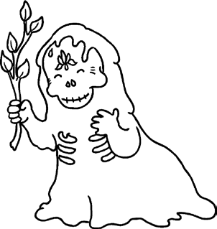  1.18m

Complete the statements by writing < or > in each box.

1.97m
1.32m
1.50m
1.76m
1.50m
1.05m

1.18m
1.05m
1.97m
1.18m
1.76m
1.32m

visit twinkl.com

