- a) Complete the statements to match this place value grid:

Ones | tenths | hundredths

ones, tenths, hundredths

is the number.

b) Complete the place value grid to show this number:

four ones, six tenths, three hundredths

Ones | tenths | hundredths

is the number.

- Write the letter for each decimal next to the number that contains that decimal. Each letter might match more than one number. One has been done for you.
Number | Letter(s)
2.68
15.15 | a
6.52
13.33
5.52

  - five hundredths
  - six tenths

  - five ones
  - three tenths
  - five tenths
  - six ones

- Complete the different part-whole models and the matching number statements.

1.68

1.68

1.68

1.68

1.22
0.33
1.6

1.22 + = 1.68
+ 0.33 = 1.68
1.6 + = 1.68
+ = 1.68

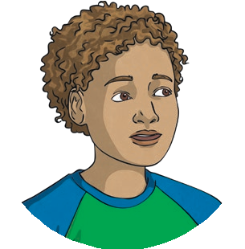

1)
1.24 is my number.
I added 1 tenth to my number.
1.27 is my new number.

Is Peter correct? If not, explain the mistake he has made and give the correct answer.

Peter is not correct as if he added a tenth it would= 1.34.

2)
3.09 is my number. This is made up of three ones and nine tenths.

Is Liliana correct? If not, explain the mistake she has made and give the correct answer
Liliana is not correct as her number has hundredths and so the mistake was that she got the

Tenths mixed up with hundredths.

3) Here are four numbers. Circle the odd one out and explain why it is different to the rest.

1.54 2.51 3.45 1.59

The odd one out is 3.45 as in the tenths Colum there’s 50 instead of 50

- Here are some clues about a mystery number.

  - There are four digits in total.
  - The largest digit is a hundredth.
  - There are no ones.
  - The tenths digit and the tens digit are the same.

- Which of these could be the mystery number? Hint: there is more than one.
3.75
10.18
60.44
20.25
15.17

- Choose one of the possible mystery numbers.
Write another clue that would mean only this number is the right answer.

As in 3.75 there are 3 digits in totall

- a) Four children have written down a number. Under each number write the name of the person describing it.

17.08
12.5
2.35
11.97

My number has five
hundredths.
My numbr has an even number of ones.

My number has two decimal places, but no tenths.

My number has fewer
hundredths than tenths.

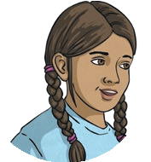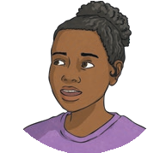

b) Write 4 different numbers which would fit this clue:
My number is greater than 10, has two decimal places and no
ones.
The tenths digit is greater than the hundredths digit.

