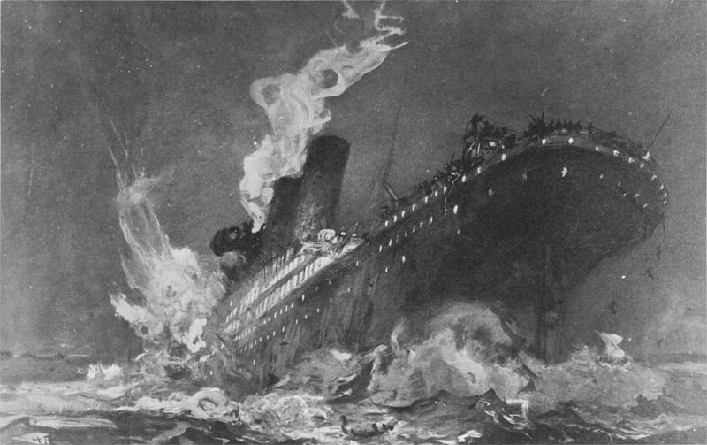
Drawing by Henry Reuterdahl, based on survivors’ stories, 1912

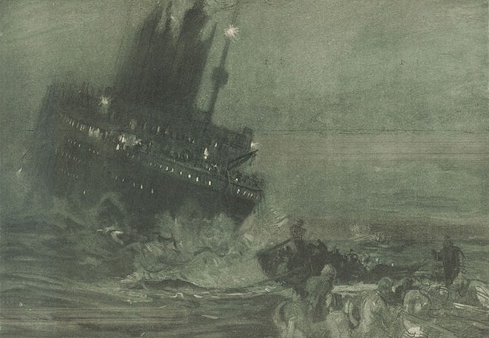
Drawing by Henry Reuterdahl, based on survivors’ stories, 1912
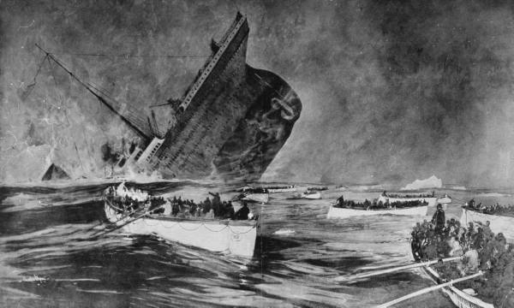
Drawing by Henry Reuterdahl, based on survivors’ stories, 1912

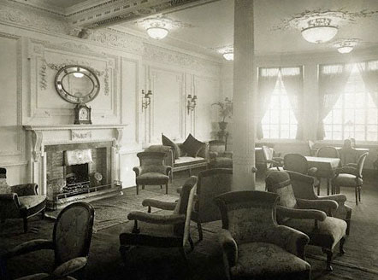
Olympic’s library and reading room, 1912
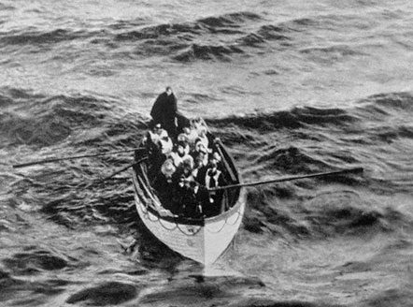
Survivors, photographed from the rescue ship, Carpathia, April 15th 1912

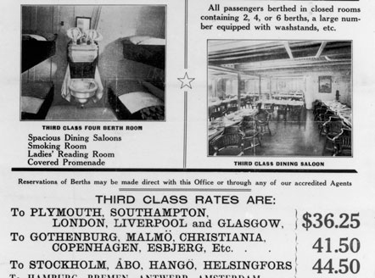
Brouchure advertising Titanic, January 1912
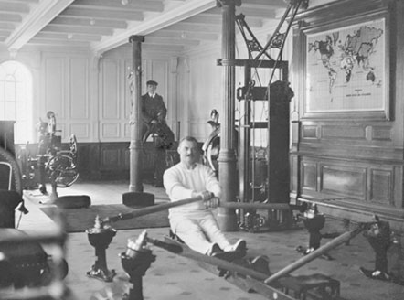
Gym onboard Titanic, 1912

Second class lunch menu, 1912
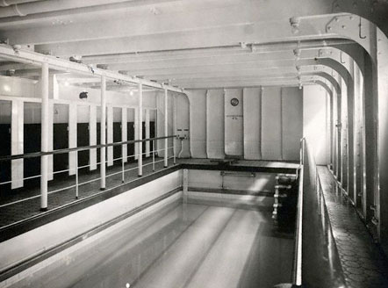
Titanic swimming pool - the first ever pool onboard a ship, 1912

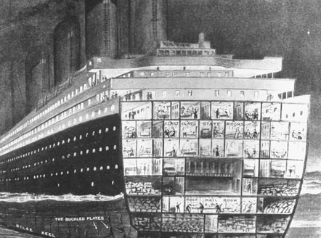
Illustrated cross-section of Titanic from Time Magazine, 1912
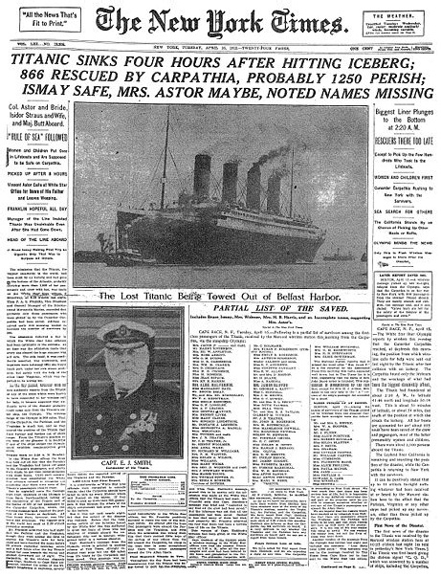
New York Times newspaper, April 16th 1912

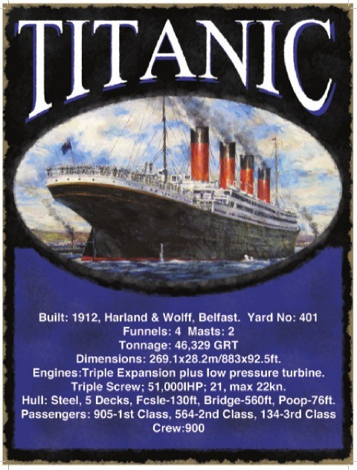
Poster advertising Titanic’s statistics, 1996

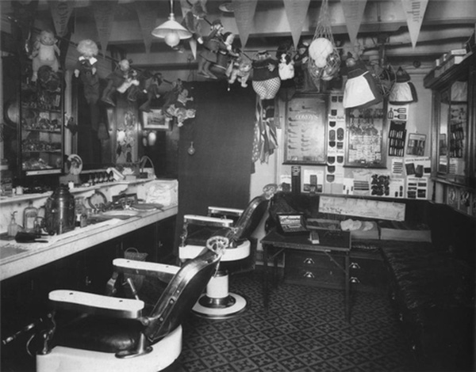
Hair dresser’s onboard Olympic, 1914

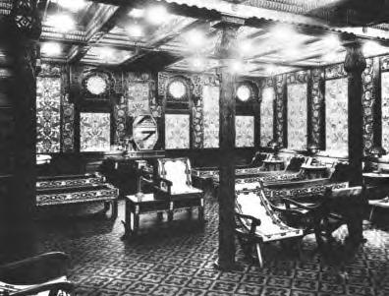
Steam room and spa onboard Titanic, 1912

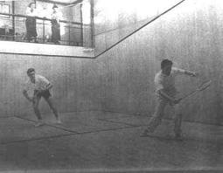
Squash court onboard Olympic, 1913

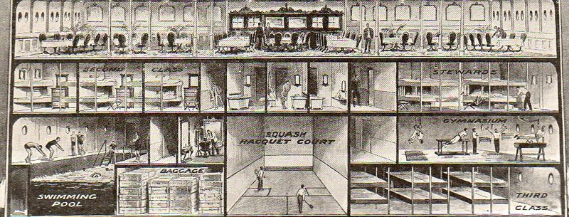
Deck plans of Titanic, 1911

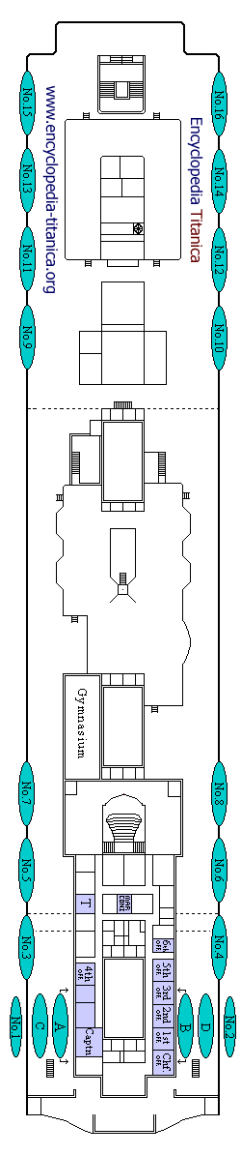

Fact File:

Modern drawing of deck plan showing lifeboats, 2012
Fact File
- The Titanic was 882 feet, 8 inches long (the length of three football pitches), and 92 feet, 6 inches wide.
- The Titanic's whistles could be heard 100 miles away.
- The Titanic had a heated swimming pool on its decks, the first ever on a boat.
- The R.M.S. in R.M.S. Titanic stands for Royal Mail Steamer. Besides carrying passengers, the Titanic's main purpose was carrying mail between Europe and America.
- It's a tradition to "christen" a ship by breaking a bottle of champagne on its bow, but the Titanic was never christened.
- The Titanic struck the iceberg at 11:40 p.m. on Sunday, April 14, 1912. It sank 2 hours, 40 minutes later at 2:20 a.m. on Monday, April 15.
- The Titanic could carry 3,547 people. It was carrying 2,229 passengers on its first and final trip.
- Women and children were rescued first. At least one man disguised himself as a woman to get onto the lifeboats.
- The ship the Californian was just 6 miles away from the Titanic. Its radio operator went to bed ten minutes before the Titanic sent out distress signals. The Titanic fired distress flares, too, but people on the Californian thought they were just having a party.
- After the Titanic disaster, many changes were made to improve ship safety. All ships must carry enough lifeboats for every passenger on board. Ships' radios are manned 24 hours a day. Regular lifeboat drills are held, and speed is reduced in ice, fog, or any other dangerous weather conditions.

Taken from Titanic Encyclopaedia website, 2012

Passenger Information
Passengers on board | 1’316
Crew on board | 913
Total on board | 2’229
Died | 1’516
Suvived | 713

Taken from Titanic Encyclopaedia website, 2012

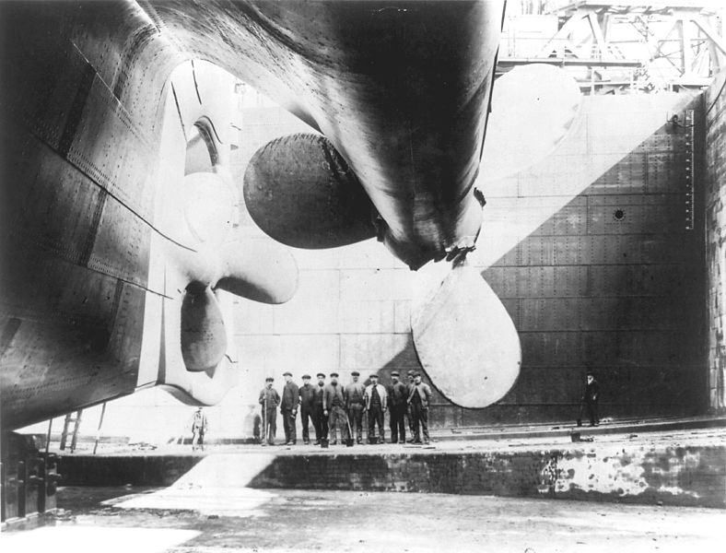
One of Titanic’s three colossal propellers, 1911

I was lying in bed, when suddenly a strange quivering ran under me, apparently along the whole length of the ship. Startled by the shivering motion, I sprang to the floor. With too perfect a trust in that mighty vessel, I went back to bed. Someone knocked at my door and the voice of a friend said, “come quickly to my cabin; an iceberg has just passed our window! I know we have just struck it”
Elizabeth Shute’s testimony after the sinking, 1912

Suddenly I saw the Titanic give a curious shiver. The night was perfectly clear. There was no fog, and I think we were a thousand feet away. Everything could be clearly seen. There were no lights on the lifeboats except a few lanterns which had been lighted by those on board.
Almost immediately after the boat gave this shiver we heard several pistol shots and a great screaming arose from the decks.
The back of the boat lifted in the air and there was a tremendous explosion. Then the Titanic dropped back again. The awful screaming continued. Ten minutes after this there was another explosion. The whole forward part of the great liner dropped down under the waves. The stern rose a hundred feet, almost perpendicularly. The boat stood up like an enormous black finger against the sky. The screaming was agonizing. I never heard such a continued chorus of utter despair and agony.
Then there was another great explosion and the great stern of the Titanic sank as though a great hand was pushing it gently down under the waves. As it went, the screaming of the poor souls left on board seemed to grow louder. It took the Titanic but a short time to sink after that last explosion. It went down slowly without a ripple.
It was at least an hour before the last shrieks died out. I remember next the very last cry was that of a man who had been calling, loudly: 'My God! My God!' He cried monotonously, in a dull, hopeless way. For an entire hour there had been an awful chorus of shrieks gradually dying into a hopeless moan until this last cry that I spoke of. Then all was silent. When the awful silence came we waited gloomily in the boats throughout the rest of the night.
Lady Duff Gordon’s testimony after the sinking, 1912

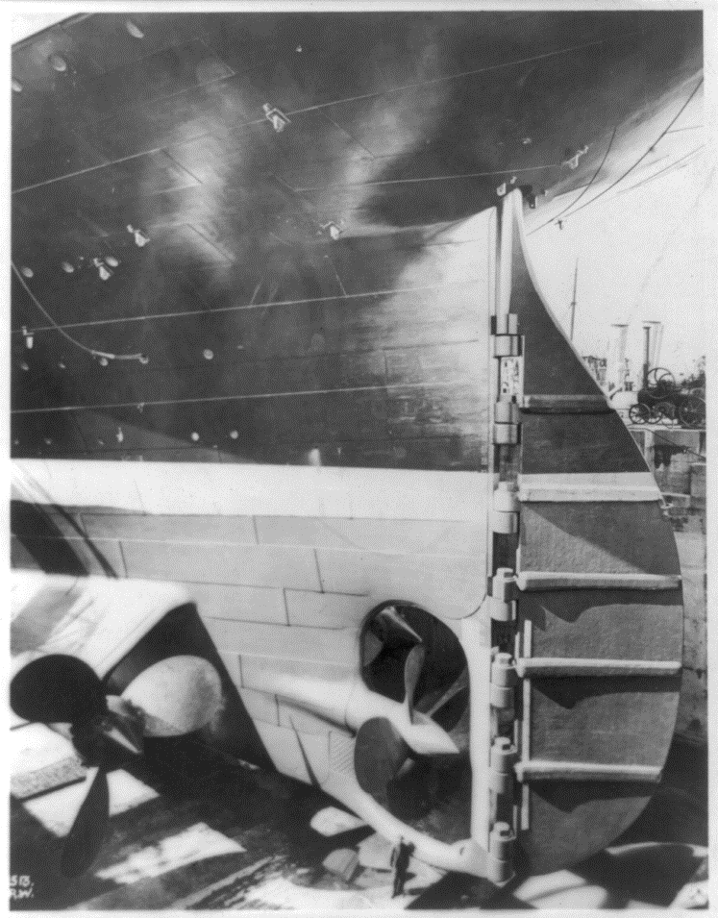
Titanic’s rudder – used to steer the boat. Tiny compared to the rest of the ship! Did this affect the steering? 1911
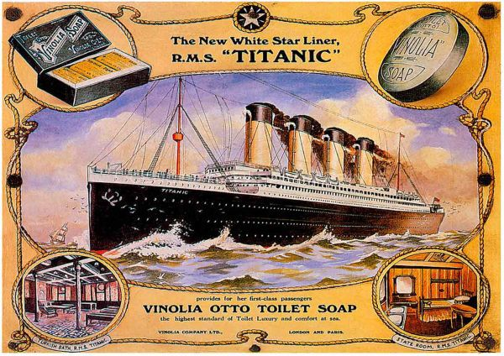
Advertisement for ‘toilet luxury’ on Titanic, 1912

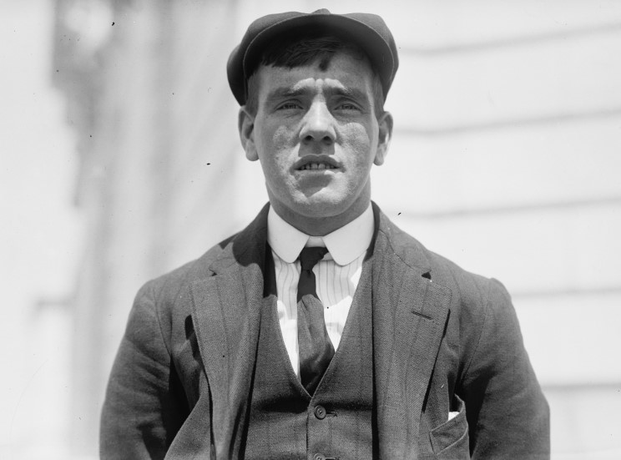
Frederick Fleet – Look Out (survived)

It was nearly midnight. I was on the night shift in the crow’s nest. The sea was as smooth as a pond and the sky brilliant with stars. It was freezing. All I could see was my breath. I didn’t have my binoculars because they’d been locked in a cupboard and no-one knew where the keys were.
Suddenly, I spotted the towering grey mountain of ice dead ahead. It came out of nowhere. I would have seen it sooner if I’d had a pair of binoculars!
I rang to the bridge as fast as I could. “Iceberg, right ahead!” I shouted down the telephone. And then I waited. The ice berg was only a mile away. There was nothing I could do now. I braced myself against the mast for the collision.

Was Frederick Fleet most responsible for the loss of life on Titanic?

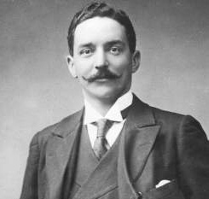
Bruce Ismay – Manager of White Star Line (survived)
Some people say they heard me persuading Captain Smith to go faster. This is not true. I have always said that it is not the speed of the ship that matters, but how luxurious it is. It was certainly not my fault that the ship was travelling so fast when we hit the iceberg!
Titanic had more lifeboats than it legally required. I was even happy to include four collapsible boats. It still wasn’t enough, I accept that, and I’m terribly sorry for those who didn’t get to a boat, but the ship sank so quickly, we wouldn’t have had time to fit any more people in anyway!
I helped as many people as I could into boats before I got in one myself. There were no more women or children around. I felt that I could be of more help to the survivors than to those still on the ship. From now on, White Star Line will include enough boats for everybody.

Was Bruce Ismay most responsible for the loss of life on Titanic?

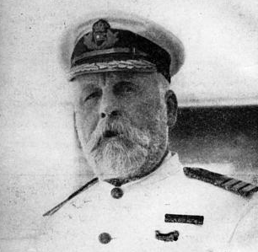
Edward Smith – Captain (died)
I was a highly experienced captain. In fact, I even helped to avoid a disaster in Southampton as the Titanic set sail! The size of the ship meant that when it moved forward, it sucked a smaller boat towards it. It was thanks to me that we swerved out of the way in time!
The only reason we were travelling so quickly when we hit the iceberg was because the water was so calm and the sky so clear. My wireless operator did mention that there was ice in the area, but it is usually much smaller than the berg we hit. If I’d have known, I’d have slowed down, of course!
When we sank, I helped as many women and children into boats as I could. The last anyone saw of me was helping a child into a boat, then drifting away into the icy waters...

Was Captain Smith most responsible for the loss of life on Titanic?
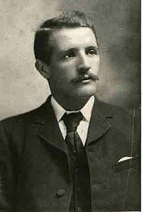
William Murdoch – Chief Officer (died)
I was on the bridge when the call came through – “iceberg right ahead!” I immediately ordered the ship to turn starboard (left) in the hope that we would avoid hitting it. I then sent a call through to the engine room, telling them to reverse the engines to slow us down. I closed all of the watertight doors below decks to seal any punctured compartments.
There are some people who think that if we had hit the iceberg straight on, it would only have damaged the front of the ship and we’d stay afloat. But my training has always taught me to try to avoid hitting icebergs.
Maybe if I hadn’t reversed the engines, we would have turned quicker, I don’t know! But I did everything I could.

Was Officer Murdoch most responsible for the loss of life on Titanic?

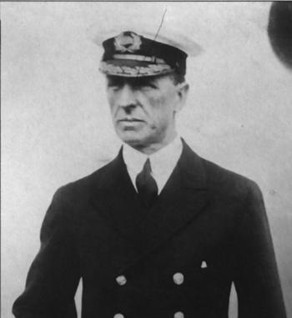
Stanley Lord – Captain of S.S. Californian
We had stopped our ship, the S.S. Californian, for the night because the sea was filled with pack ice.
Before we went to bed, our telegraph operator sent a message to a large ship about ten miles away, warning it that there was ice about. It was the Titanic. They told us to stop messaging them, as they had a backlog of messages to send to passengers’ relatives in New York.
Later that night, my Second Officer noticed rockets being fired from the Titanic. He tried to signal using a flash light, but got no response. We never thought to switch the radio on. Several more rockets were fired, and the ship did look rather strange. Then, gradually, it seemed to disappear, as though it was sailing away... I decided to try to get in touch with them in the morning.
I didn’t know it had sunk, otherwise I would have helped!

Was Captain Stanley Lord most responsible for the loss of life on Titanic?

