Plotting Co-ordinates in four quadrants
Question 1
Plot the following co-ordinates on your grid. (remember to use a ruler!)
A (5, 2)
B (4, 4)
C (-1, 2)
D (-2, -3)
E (2. -5) Join E back to A
What is the name of this shape?
__________________________
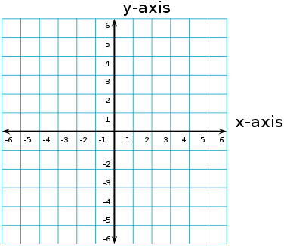
Question 2
Plot the following co-ordinates on your grid. (remember to use a ruler!)
A (3, 5)
B (0, 6)
C (-3, 5)
D (0, -5) Join D back to A
What is the name of this quadrilateral? _______________
Question 3
Plot the following co-ordinates on your grid. (remember to use a ruler!)
A (-2, 5) B (2, 5)
C (4, 3) D (4, -1)
E (2,-5) F (-2, -5)
G (-4, -1) H (-4, 3)
Join H to A
What is the name of this shape? ___________________________
Plotting Co-ordinates in four quadrants ANSWERS
Question 1
Plot the following co-ordinates on your grid. (remember to use a ruler!)
A (5, 2)
B (4, 4)
C (-1, 2)
D (-2, -3)
E (2. -5) Join E back to A
What is the name of this shape?
____Pentagon____
Question 2
Plot the following co-ordinates on your grid. (remember to use a ruler!)
A (3, 5)
B (0, 6)
C (-3, 5)
D (0, -5) join D back to A
What is the name of this quadrilateral? ___Kite___
Question 3
Plot the following co-ordinates on your grid. (remember to use a ruler!)
A (-2, 5) B (2, 5)
C (4, 3) D (4, -1)
E (2,-5) F (-2, -5)
G (-4, -1) H (-4, 3)
Join H to A
What is the name of this shape? ____Octagon_____

