**Origami**

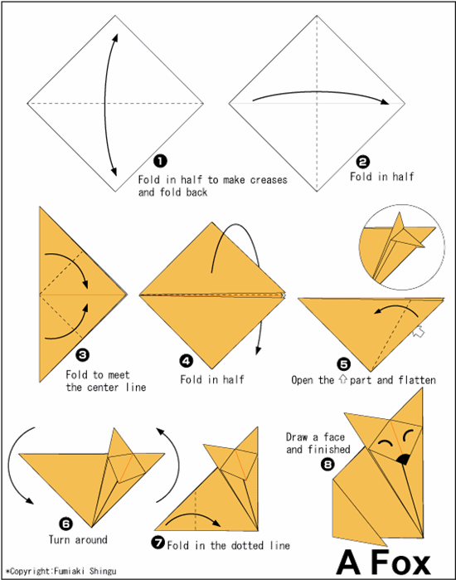

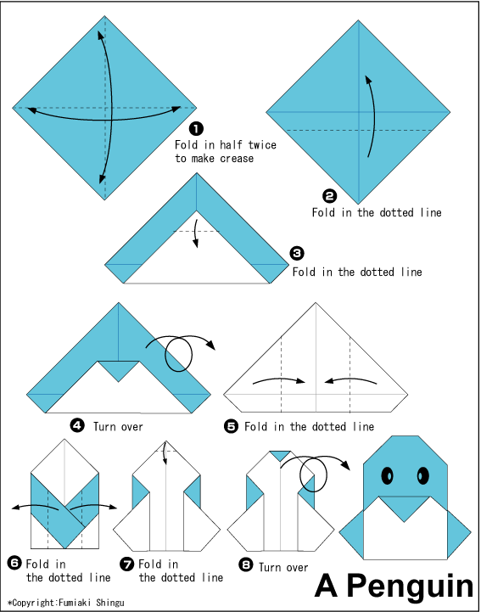

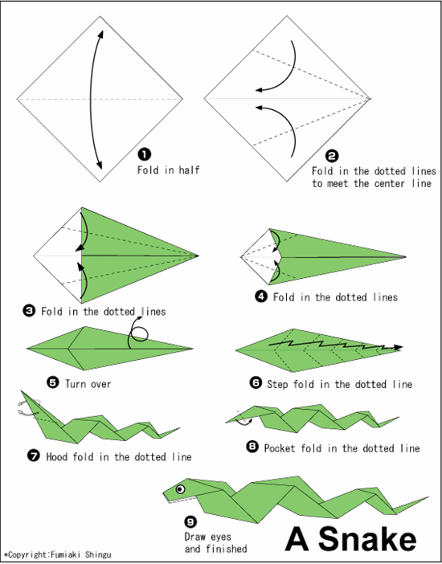

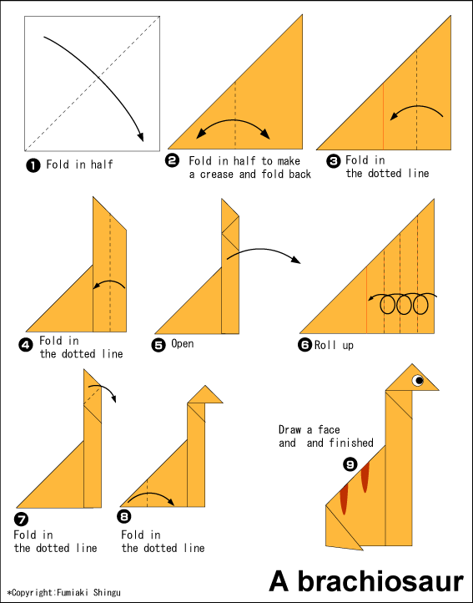

[All Images](http://en.origami-club.com/shingu/), By Fumiaki Shingu is licensed under [CC By 2.0](http://creativecommons.org/licenses/by/2.0/)