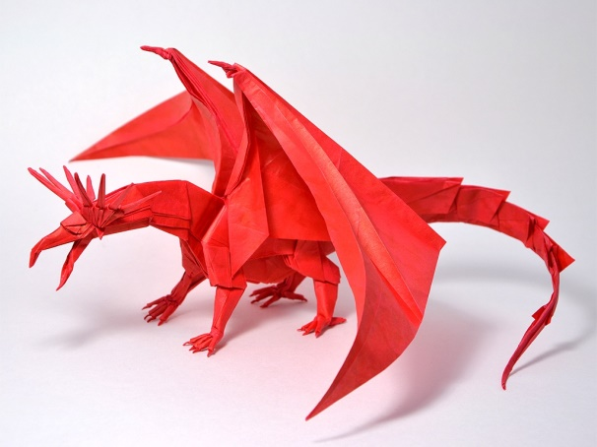
Origami is the Japanese art of paper folding. ‘Ori’ is Japanese for folding and ‘kami’ is Japanese for paper.
Playing With Paper
You may be surprised to learn that origami actually originated from China. Around 100 AD the Chinese invented paper and the invention spread to Japan around 600 AD along with the art of paper folding.

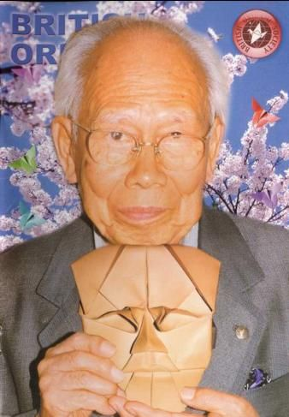
Due to the scarcity of paper, Origami in ancient times was used only at special occasions. The paper was formed into animals, costumed people and ceremonial designs with special meanings to them. The forms where often, but not always, made from square pieces of paper, and always a single sheet.
None of the folding instructions where written down back then, they were handed down through generation to generation through learning and practicing.
The art of paper folding wasn’t given the name origami until the end of the nineteenth century. Akira Yoshizwa (1911 – 2005) helped origami popularity in the 1950’s. He is considered the grandmaster of origami for developing origami as a creative art and fashioning new folding styles.
Figure 54
Have a go a fold some of your own origami using the designs on the separate sheet:

