Money

 | Learn and revise
These are the coins we use: |  |  | 2p  50p
There are 100 pence in £1. |  | 1p |  |  | 5p | 10p |  | 20p
£1 = 100p
£2 = 200p  £1 and 50p = 150p |  |  |  |  | £1 |  | £2

Practice activities

- How much money is in each purse?
  - b) c)

20p

50p 1p

10p

10p
2p

5p 5p

1p
2p

50p

20p 5p 1p
10p 10p
5p 5p 2p
1p 1p 2p
2p

20p 5p
1p 1p

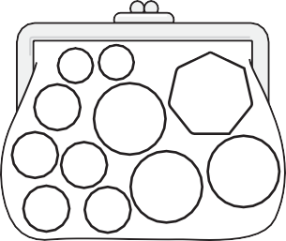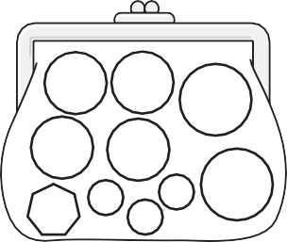
p p p
- Answer these.
  - A pencil costs 50p and you use four coins to pay for it. Which coins could you use?

  - A ball costs 80p and you have a 20p coin in your hand. You use two more coins to make the total. Which coins did you use?

  - A balloon costs 75p and you have a 10p coin in your hand. You use five more coins to make the total. Which coins did you use?

- Make up the following amounts with the fewest number of coins.
  - 85p

b) 124p

c) 99p

46

