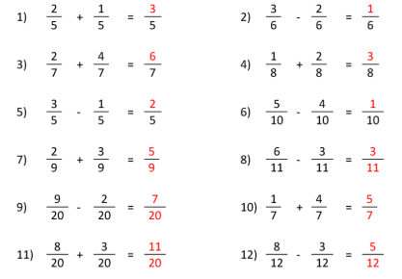

Did you remember that we leave the denominator as it is if they are the same?

