Name........................................................................
Age............................. Year...................

My favourite place in school:
____________________
____________________
____________________

My favourite subject:

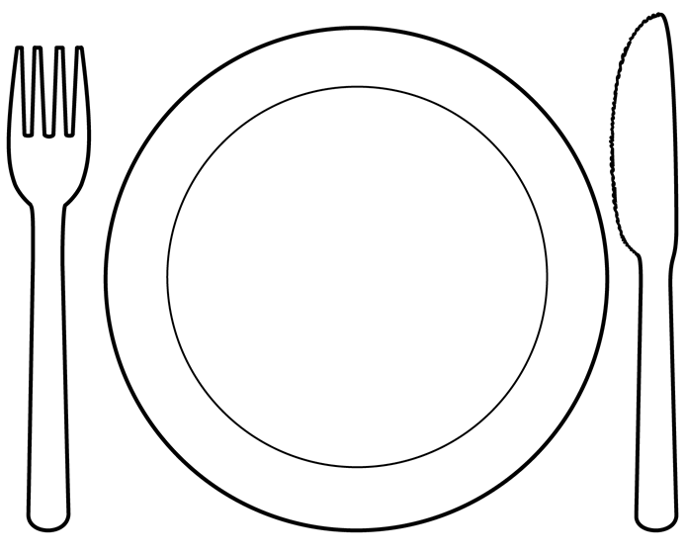

My favourite book:
_____________________
_____________________
_____________________

My favourite school lunch:
________________________
________________________

- __________________________
- __________________________
- __________________________
- __________________________

My best memory in Reception is: ____________________________________________________
____________________________________________________
____________________________________________________
____________________________________________________
My best memory in KS1 is: ____________________________________________________
____________________________________________________
____________________________________________________
____________________________________________________
My best memory in Year 3 is: ____________________________________________________
____________________________________________________
____________________________________________________
____________________________________________________
My best memory in Year 4 is: ____________________________________________________
____________________________________________________
____________________________________________________
____________________________________________________
My best memory is Year 5 is: ____________________________________________________
____________________________________________________
____________________________________________________
____________________________________________________
My best memory in Year 6 is: ____________________________________________________
____________________________________________________
____________________________________________________
____________________________________________________

________________________________________________________________________________________________________________________

________________________________________________________________________________________________________________________

__________________________________________________________________________________________

My best friends are: ____________________________________ ____________________________________________________________________________________________________________________________________________________________

