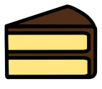
1. I cut my cake into 16 pieces to share with my friends. There are four of us altogether. How many pieces will we each get?
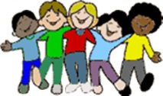
2. There are 24 children in the class. They need to be split into 4 groups. How many children will there be in each group?
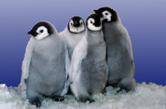
3. Thirty six penguins need to be put into 3 pools. How many will go in each pool?
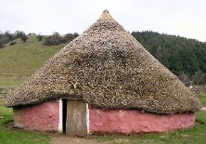
4. There are 32 Anglo-Saxons living in 8 round houses. How many live in each house?
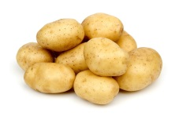
5. There are 48 potatoes left in the pan and 4 children in the queue. How many potatoes will they each get?
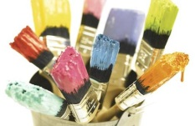
6. There are 36 paint brushes in the cupboard and 3 pots. How many paint brushes should go in each pot?
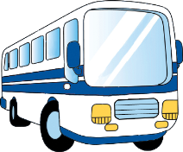
7. 64 children need to go to the swimming baths. Two buses are sent to take them there. How many children should go on each bus?
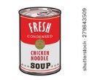
8. A supermarket has 4 shelves for soup and 84 tins to put on them. How many tins should they put on each shelf?

