Coca Beans to Chocolate Bar.
Coca beans grow on a coco tree. Once they are ripe they are harvested. They then proceed into a roster where they are roasted for 30 minutes at 160 degrees. Then they go to a cooler.
The soft shell is then removed in the winnower. They then remove the nibs.
Then they are placed in the grinder for 10 minutes. They are now taken into a second grinder where it is ground into finder powder.

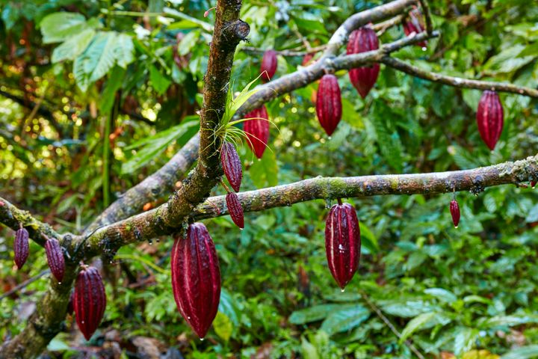

Sugar is now added at 44 percent is added depending on the weight. It is then placed in the mixer for 15 minutes till the mixture is smooth. Next it goes in the conch for a whopping 12 hours. Cocoa butter is added. Then in the conch for another 4 hours. It goes into the tempering machine at 40 degrees C then 28 degrees C then 31 degrees C. The mixture is poured into the injector, which injects the mixture into the moulds. The next stage it goes to the freezer. Then it’s bought back to a wrapping machine Which can wrap up to 100 bars per minute. And then place in boxes to be sent off the stores. Where you can purchase the chocolate and thoroughly enjoy yourself.

