Cut out each period of British history and create a timeline with them in the correct order.

Roman Britain  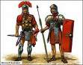  43 AD- 410 AD | Victorian Britain  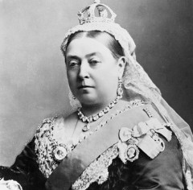  1839AD- 1901 AD | Tudor Britain  1485 AD- 1603 AD | Viking Invasions  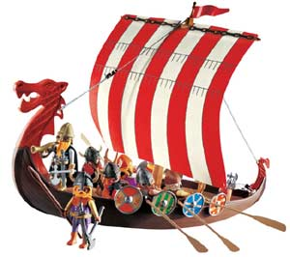  787 AD-1100AD | Georgian Britain  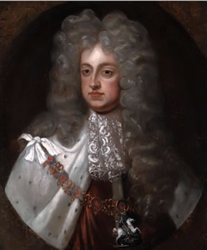  1714 AD- 1834 AD
Modern Britain  Including World War 1&2  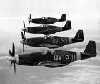  1902AD – 2014 AD | Anglo-Saxon Britain  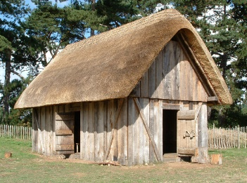  450AD- 1066AD | Pre-historic Britain  500000 BC- 4000BC | Medieval Britain  Normans  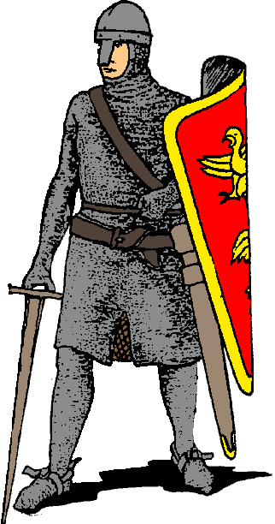  1066AD- 1485AD | Bronze Age  2300 BC - 750 BC
Stuart Britain  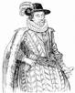  1603 AD- 1714 AD | Stone Age  4000 BC- 2300 BC | Iron Age  750 BC- 43 AD | London Olympics  2012 AD | Abolition of slavery  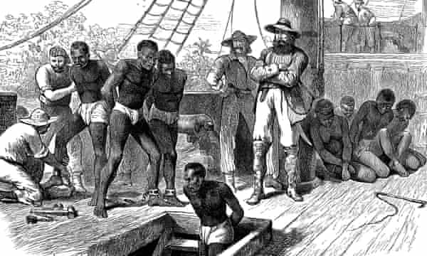  1833
Windrush arrival

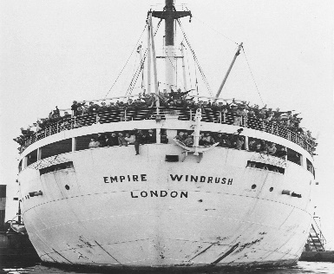

1930

