Hastings News Flash
15th October 1066

SHIELD WALL CRUMBLES

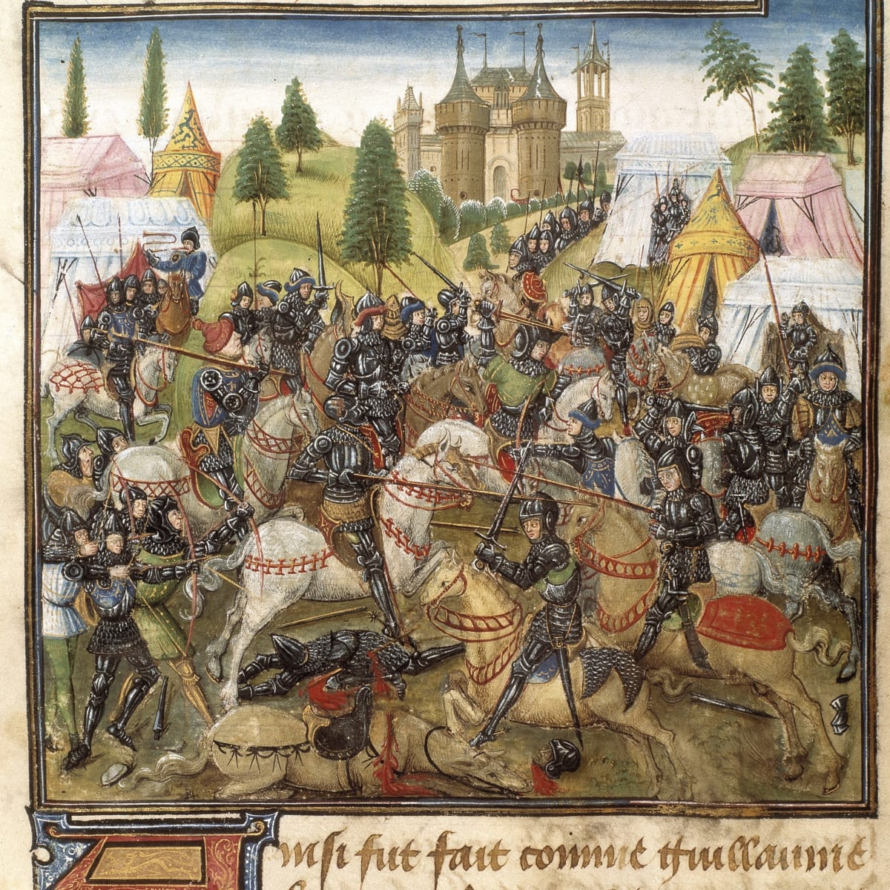
Yesterday on the 14th October, the Normans crossed the English Channel with William (Duke of Normandy) to battle King Harold for the throne of England. The battle was started in a battlefield near Hastings. Before the battle Harold told William that he could have the throne, but instead Harold was selfish by becoming King himself.
Harold and his troops marched from Yorkshire to Sussex after fighting at Stamford Bridge, to fight William at Hastings. Later that day Harold and his army saw in the distance what they thought was William seemed to be dead.

One Norman soldier told us “We thought that William was dead, it made us sad but then realised he wasn’t dead at all.” The Anglo-Saxons then decided to give up on keeping their shield wall idea and elected to fight the Normans, but soon realised that William wasn’t dead and the Norman warriors started to eliminate the Anglo-Saxon soldiers. An Anglo-Saxon soldier sadly said to us “When we thought William was dead, we made a run at the Normans but it was a ploy. My comrade Julian was cut down by a Norman soldier. I decided that it was best to retreat.”

Later that day, King Harold was killed after a Norman shot him in the eye with an arrow. William and his army walked to London after Harold died. Media reports stated that possibly in the future William will be King of England, and will establish new rules upon the English people. One Norman soldier quoted to say “Will he make it illegal for them to kill us. Let’s hope so, we won this battle fair and square”
Bella Isgar
War Correspondent
Reporting from Hastings

