Story Title Ideas – What could I call my story?

Who are my main characters? | Where is my story set?
When is my story set? | What happened at the beginning?
What was the problem in the middle of the story?. | What happened at the end?

What the characters could see.  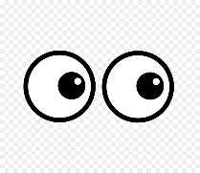 | What the characters could hear.  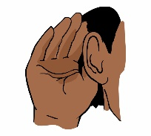
How the characters could feel. | Words I might like to include.

