Chapter 7.
A Mad Tea Party.
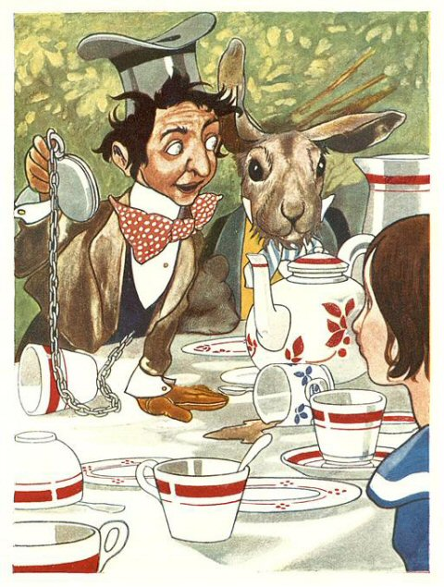
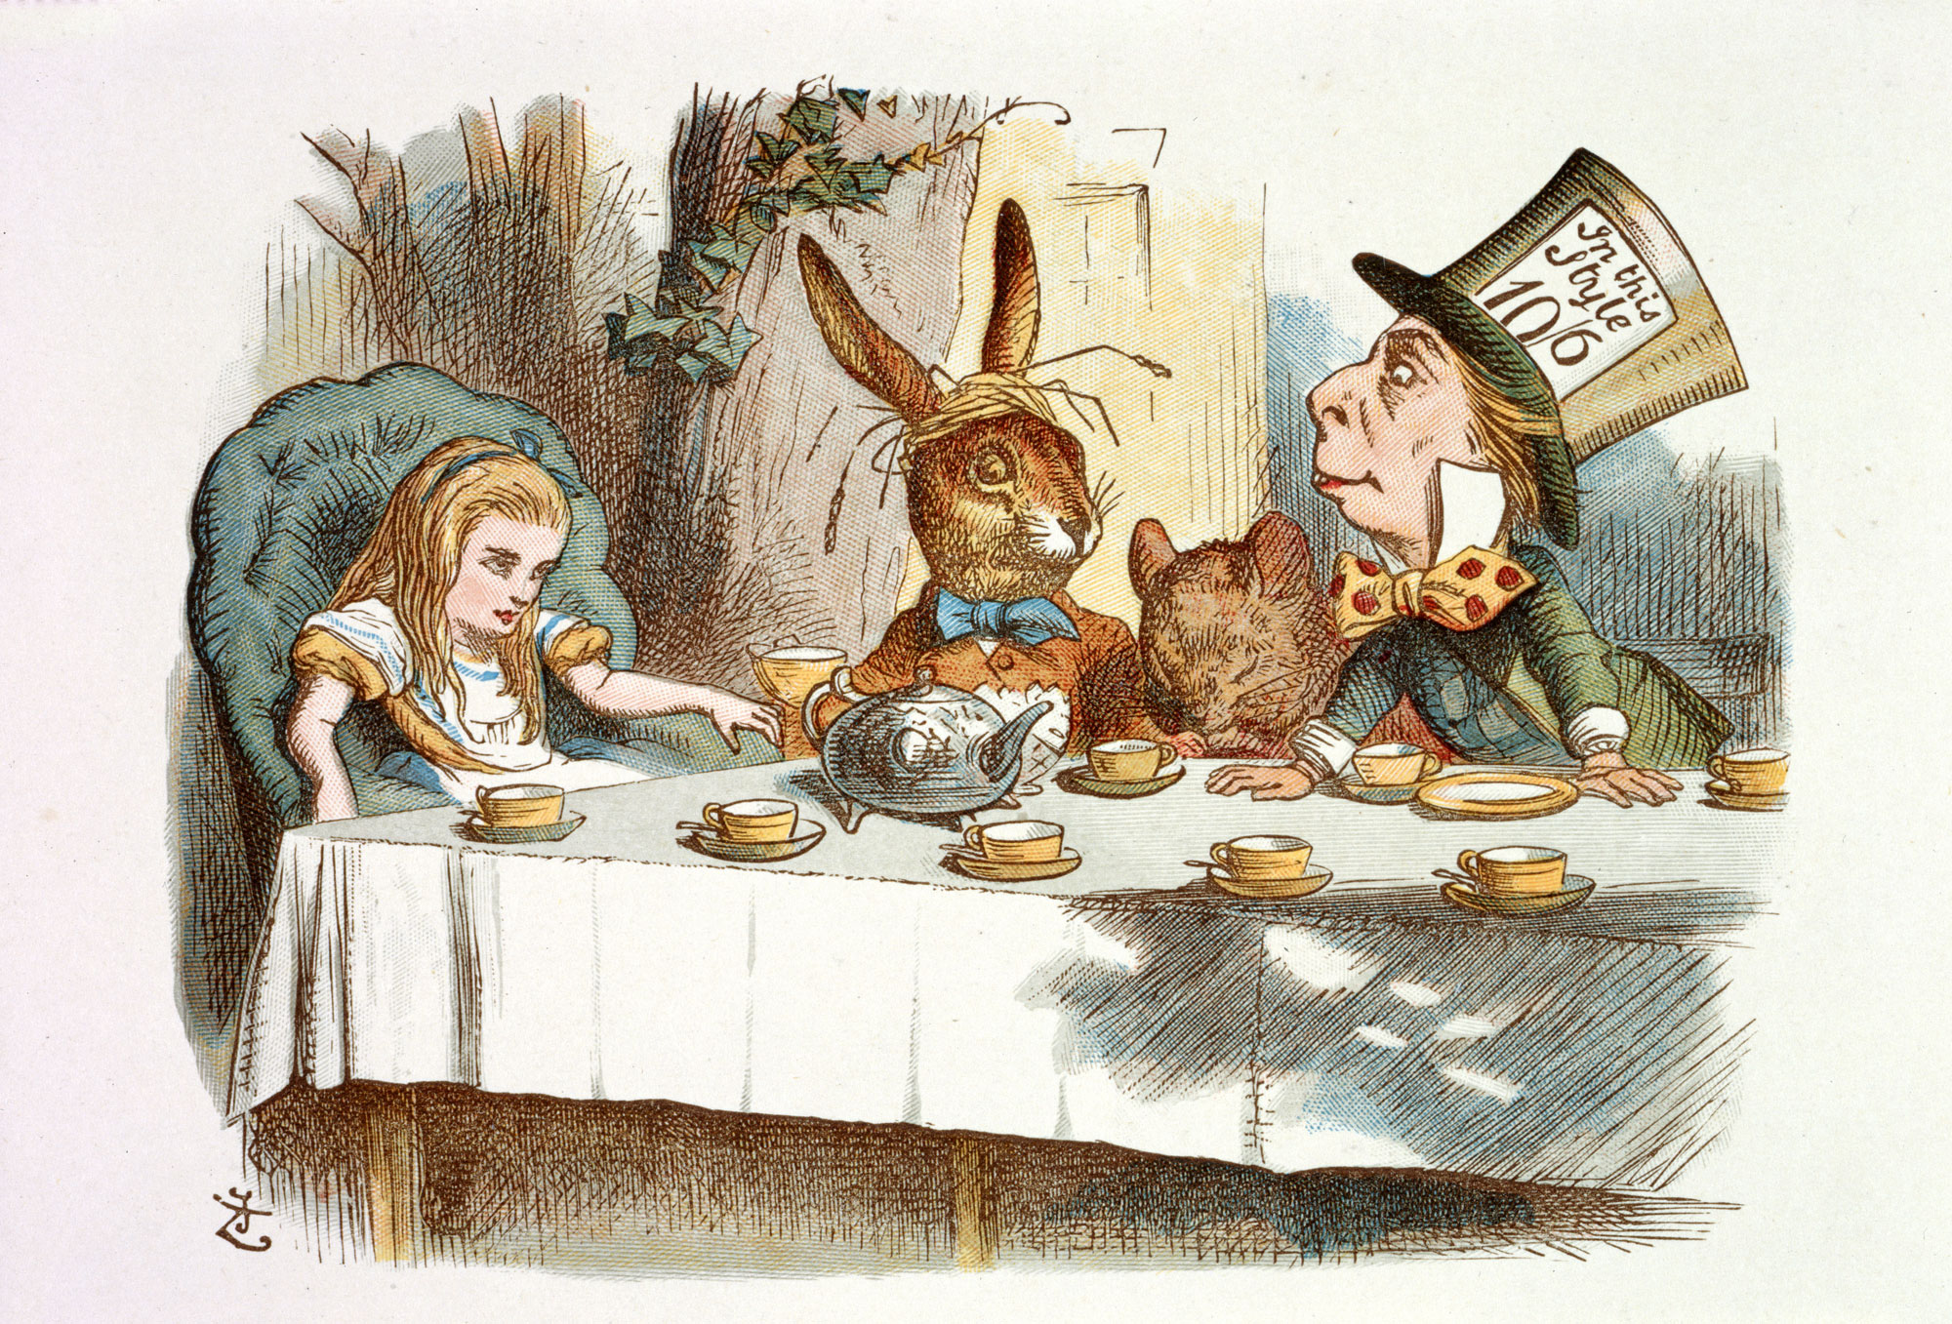

There was a table set out under a tree in front of the house, and the March Hare and the Hatter were having tea at it. A Dormouse was sitting between them, fast asleep and the other two were using it as a cushion, resting their elbows on him talking over its head. The table was a large one, but the three were all crowded together at one corner of it. “No room! No room!” they cried out when they saw Alice coming. “There’s PLENTY of room!” said Alice and she sat down in a large arm-chair at one end of the table. “Have some juice,” the March Hare said. “I don’t see any juice,” Alice remarked. “There isn’t any,” said the March Hare. “Then it wasn’t very polite of you to offer it,” said Alice angrily. “It wasn’t very polite of you to sit down without being invited,” said the March Hare. “I didn’t know it was YOUR table,” said Alice; “it’s set out for a great many more than three people.”.
“What day of the month is it?” said the Mad Hatter, turning to Alice. He had taken his watch out of his pocket and was looking at it, shaking it every now and then and holding it to his ear. The March Hare took the watch and looked at it gloomily, then he dipped it into his cup of tea and looked at it again. Alice had been looking over his shoulder with some curiosity. “What a funny watch!” she remarked. “It tells the day of the month, and doesn’t tell what o’clock it is!” said Alice. “Why should it?” muttered the Hatter. “Does YOUR watch tell you what year it is?” he asked. “Of course not, but that’s because it stays the same year for such a long time” said Alice.
“The Dormouse is asleep again” said the Hatter, and he poured a little hot tea upon its nose. The Hatter shook his head. “We quarrelled last March just before HE went mad, pointing with his tea spoon at the March Hare. “It was at the great concert given by the Queen of Hearts, and I had to sing.” The Mad Hatter stood up and started singing loudly.
“Twinkle, twinkle, little bat! How I wonder what you’re at!” “You know the song, perhaps?” he asked Alice. “I’ve heard something like it,’ said Alice. “It goes on, you know,” the Hatter continued, “up above the world you fly, like a tea-tray in the sky. Twinkle, twinkle–“.
The Dormouse shook itself, and began singing in his sleep “Twinkle, twinkle, twinkle, twinkle”. It went on so long that they had to pinch it to make it stop. “Well, I’d hardly finished the first verse,” said the Hatter, “when the Queen jumped up and shouted out, “Off with his head!”
The madness was too much for Alice and she got up and walked off. The Dormouse fell asleep instantly, and neither of the others took the least notice of her going, though she looked back once or twice. The last time she saw them, they were trying to put the Dormouse into the teapot. “I’ll never go THERE again!” said Alice. “It’s the stupidest tea-party I ever was at in all my life!”
