Year 4 Week 6 R.E
The Fruits of the Spirit.
Fruits of the spirit – sums up nine attributes of a person or community living in accord with the Holy Spirit. They are:
Love, Joy, Peace, Patience, Kindness, Goodness, Faithfulness, Gentleness and Self-control.

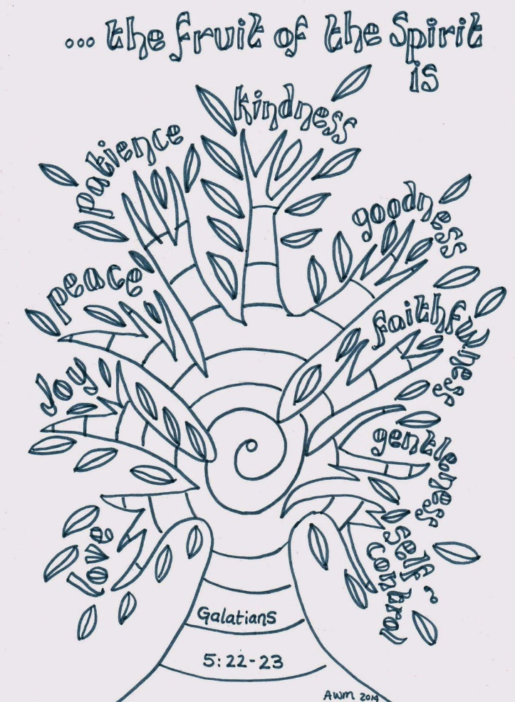

Using nine cut out leaves can you write one leaf for each fruit of the spirit telling when you have displayed these qualities. If you can’t give an example for yourself, can you think about when you have recognised and appreciated other people displaying them towards you.

