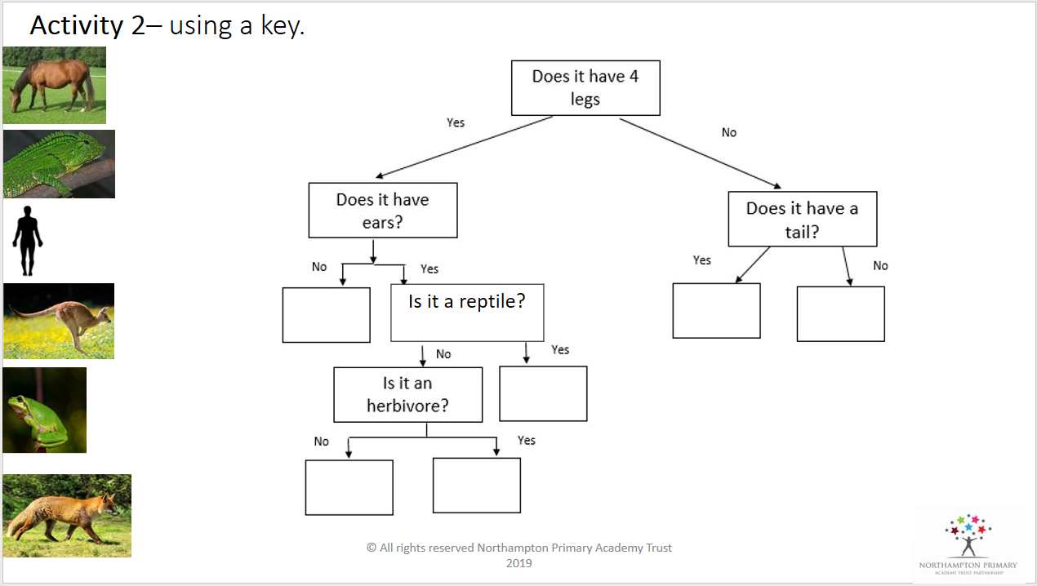
Can you complete the flow chart using the pictures provided? Can you now make a flow chart of your own? Choose some of your favourite animals to include.

