Year 4 Science Week 7.

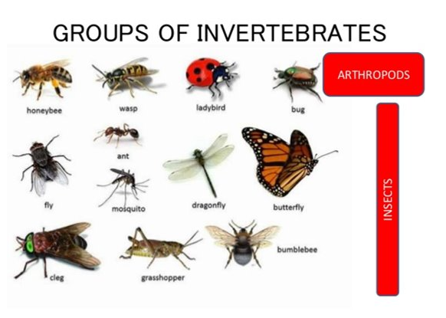

Choose your favourite invertebrate and design an information poster about it. Include a detailed, labelled drawing of the creature; tell us about all the different varieties of that creature there are, find out as much information as you can. Think carefully about presentation – make it eye catching and informative. It must contain written information as well as pictures. You can do it on paper or on the computer.

