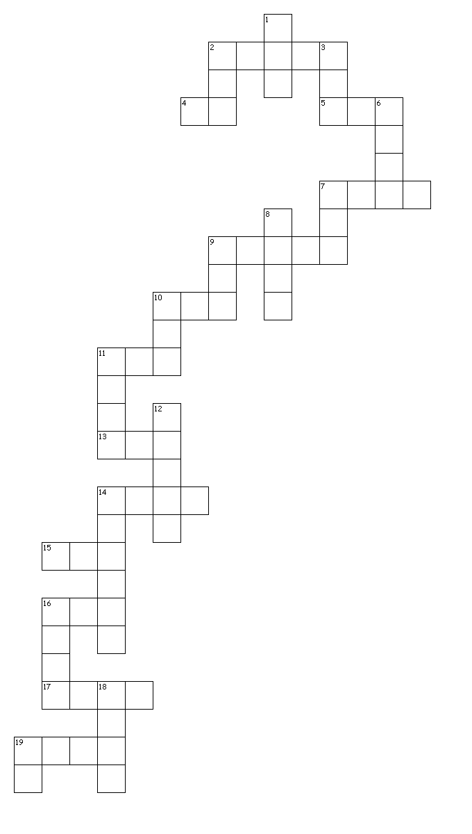
Arithmetic!

Across
2. 678 x 54
4. 630 ÷ 9 =
5. 123 × 2 =
7. 1,034 + 586 =
9. 1 and 1/5 subtract 1/4
10. 4/5 - 1/5
11. 95% of 240
13. 1/9 + 4/9
14. 7,505 divided by 5 =
15. 1.28 × 100 =
16. 1,440 ÷ 12 =
17. 2.5 + 0.05 =
19. 979 + 100 =

Down
1. 472 − 9 =
2. 20% of 1,500 =
3. 3016 divided by 13
6. 15.4 − 8.88 =
7. 5 × 4 × 7 =
8. 1/4 x 1/8
9. 2/5 divided by 2
10. 3/4 divided by 2
11. 17 x 1/2
12. 50,000 − 500 =
14. 234,897 | 45,996 =
15. 5/8 3/4 + 7/8
16. 54 x 23
18. 12 − 6.01 =
19. 20 − 4 × 2 =

