Retrieval Quiz
- Name all seven continents.
Europe, Asia, Africa, North America, South America, Antarctica, Oceania (Australia)

- What is 8²? 64

- Turn the following sentence into a passive sentence:

The man carried the box carefully.

The box was carefully carried by the man or box was carried by the man carefully.

- Circle the work that makes this a question:

Do you want to go to the shops?

- In which continent would you find Benin? Africa

- Cinco. Which number is this? 5

- Draw the symbol that is used to represent a bulb.

or 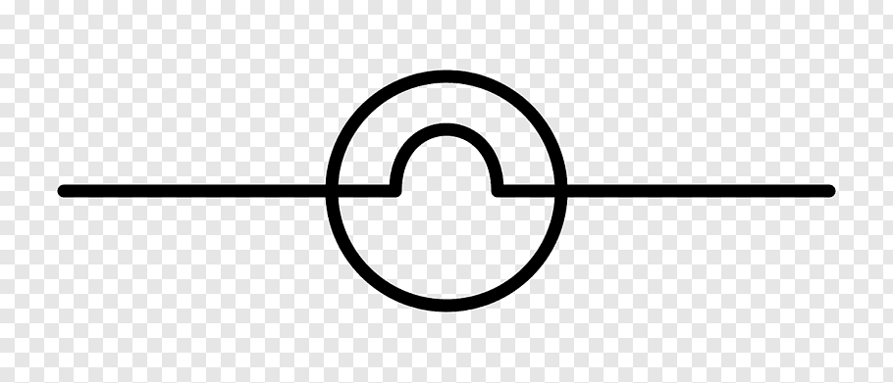

- MMMCDLXIV. Write the number. 3464

- Which food group do potatoes belong to? Carbohydrates

- How many centimetres are in 1 metre? 100

