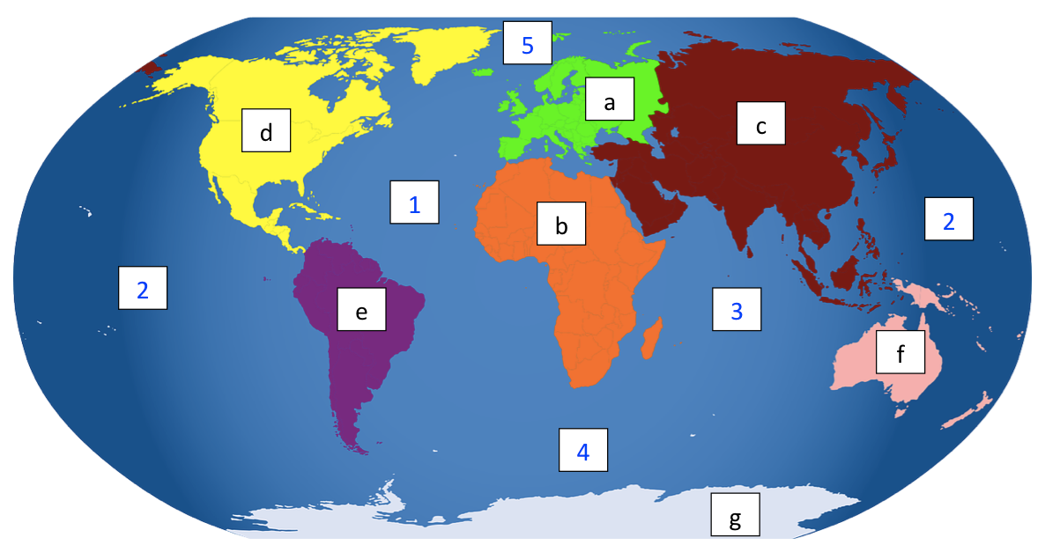
Continents:

a) _____________________________ Oceans:

b) _____________________________ 1) _____________________________

c) _____________________________ 2) _____________________________

d) _____________________________ 3) _____________________________

e) _____________________________ 4) _____________________________

f) _____________________________ 5) _____________________________

g) _____________________________

Extension: Look at an atlas or research to find out the answers.

a) Which continent is the UK in? _______________________________________

b) In which continent is Brazil? _______________________________________

c) Which continent is Egypt in? _______________________________________

