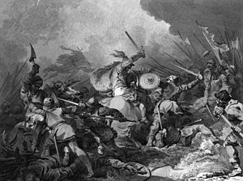
This Photo by Unknown Author is licensed under CC BY-SA
January 1066
The King of England – Edward of Confessor died.
Harold Godwinson was crowned king.
September 1066
William, the Duke of Normandy and his 700 ships fleet sailed from France to England.
William’s army pillaged and burned the area from harbour mouth.
Harold and his army raced down the country.
Harald Hardrada, the Norwegian King, invaded Northumbria in the north of England.
Harald and his army lost the battle at Stamford in Yorkshire.
14th of October 1066
The battle of Hastings
- William had 15,000 professional soldiers, well trained and equipped.
- Harald had 5,000 soldiers, tired after long march.
- Harald’s army were at the hill and build good defence- a shield wall.
- The Norman could not break through.
- Somebody spread news about William’s death among English soldiers.
- The English soldiers dropped the shield wall.
- The Normans won the battle.
- Harold was killed and buried.
December 1066
William was crowned King of England.

