Alice entered the _________ garden and she met three gardeners in the shape of playing cards. The gardeners Two, Five, and Seven were arguing with each other ______ they painted the white roses on the rose trees red. They noticed Alice, and the gardeners explained that they had planted white ______ trees by mistake and that they must ___________them red before the Queen of Hearts ________ out. Just then, the ____________ arrived, surrounded by a great group of living playing cards. The gardeners lie on their ______________ to bow before the Queen. The Queen asked ______________ about the trembling gardeners. Alice replies rudely, and the Queen __________________ “off with her head!” Alice went off ___________ the Queen to play croquet.
Alice finds it difficult understanding the curious game of croquet being ______________ by the Queen. The croquet ground is bumpy, the croquet balls are ______________ hedgehogs, and the mallets are _______________flamingos. The playing cards stand on all fours to make the arches that the balls are _____________ through. As she plays, the Queen who does not like losing starts to shout and gets _________________. Alice tries to _____________ away from the croquet match, but catches sight of the Cheshire Cat’s ______________. The Cheshire Cat asks her how she is getting on, and Alice begins to complain ______________ the Queen. The King sees the Cheshire _______ and becomes angry and calls for the Queen to remove the Cheshire Cat. The Queen orders
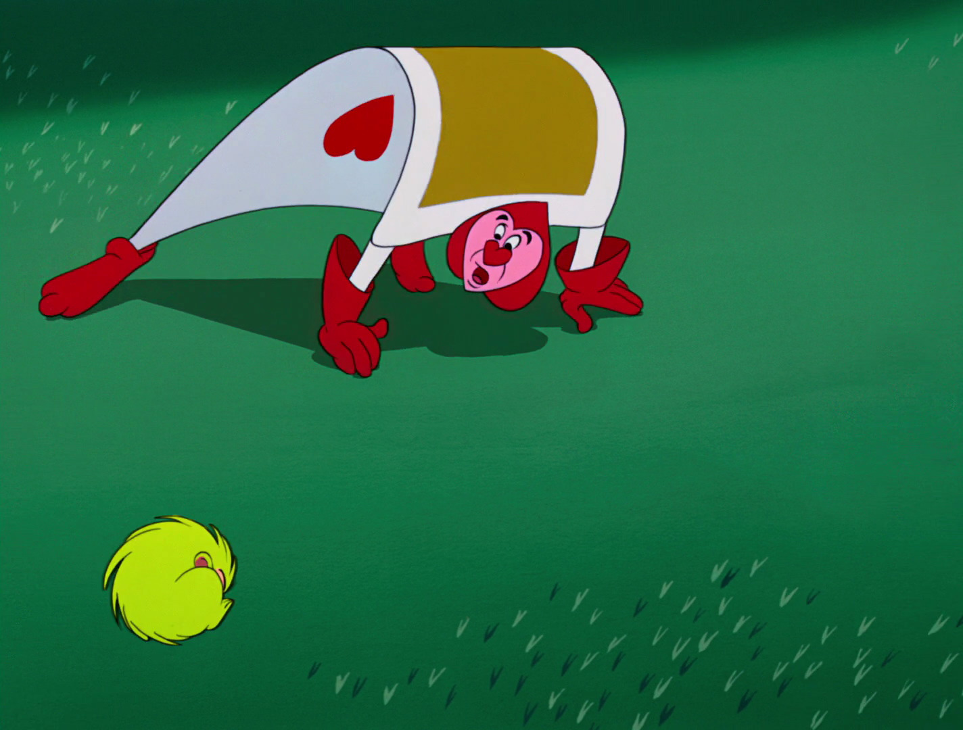
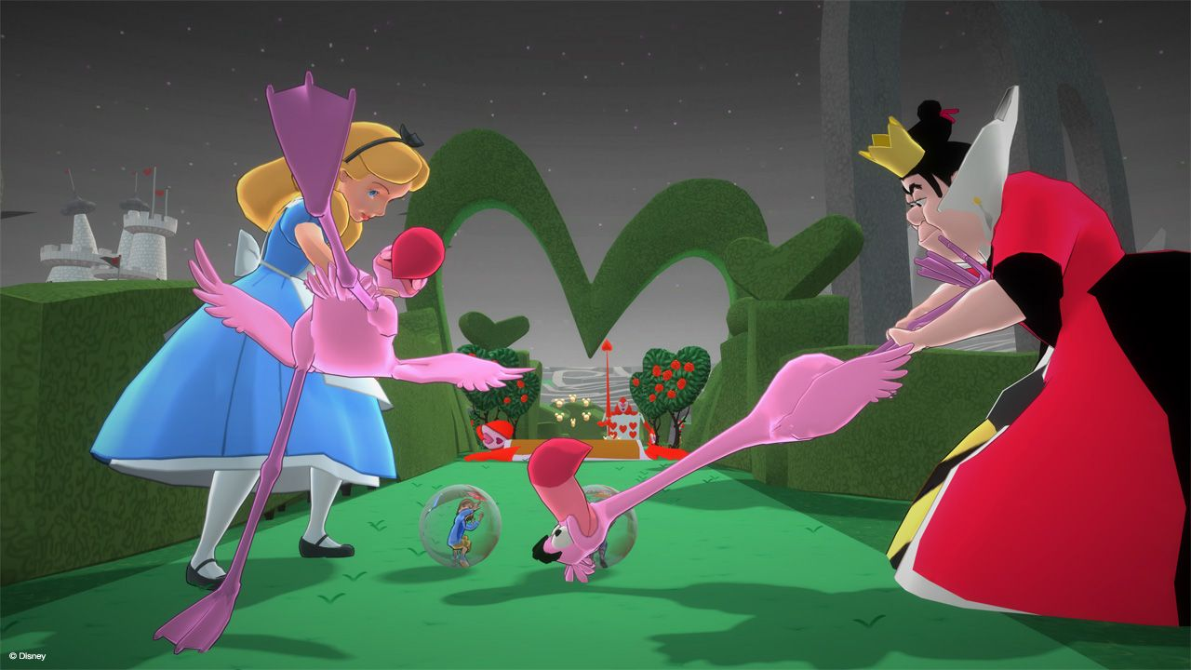
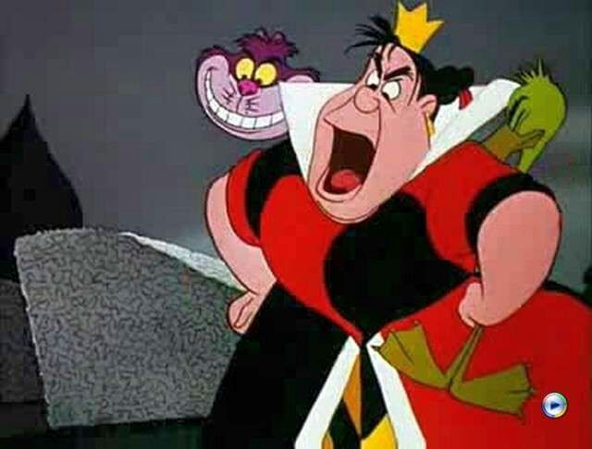
“off ______________ his head” but the Cheshire Cat completely vanishes.

