Year 4 Science Task Week 4
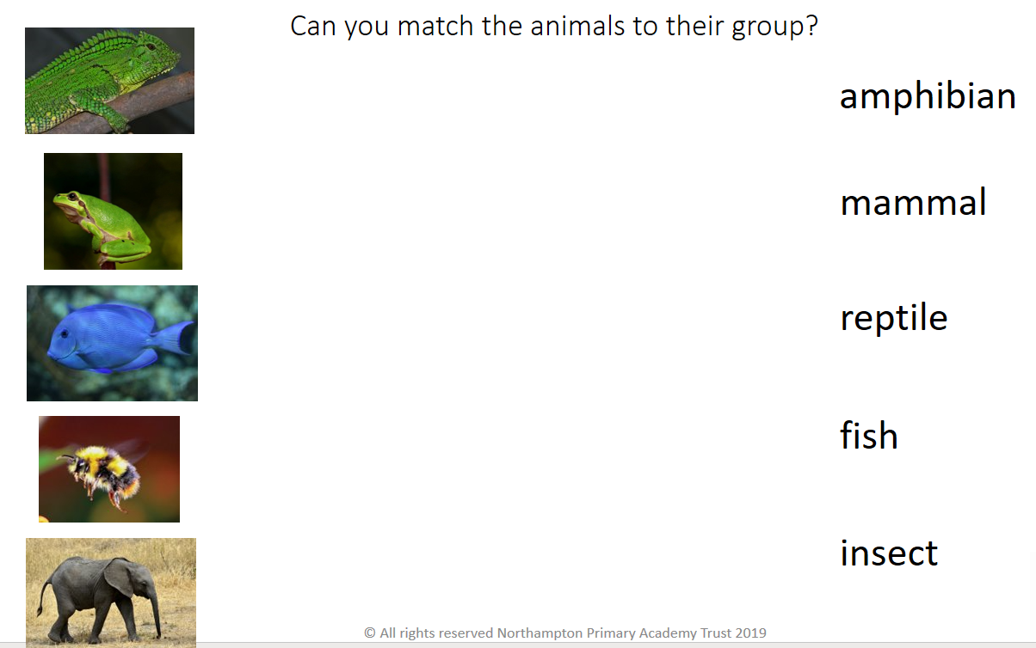
Draw a line from the animal to the correct group.

Key Vocabualry:
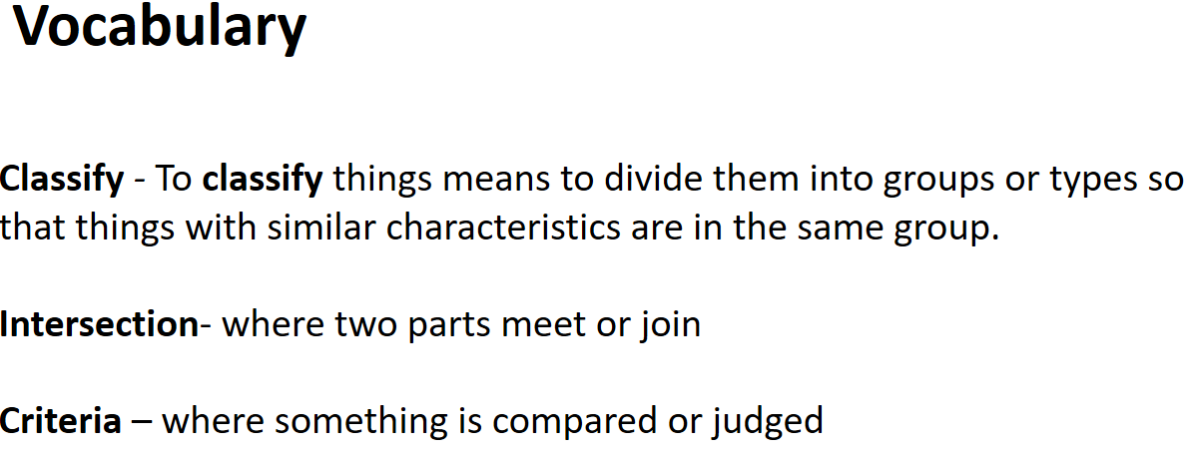

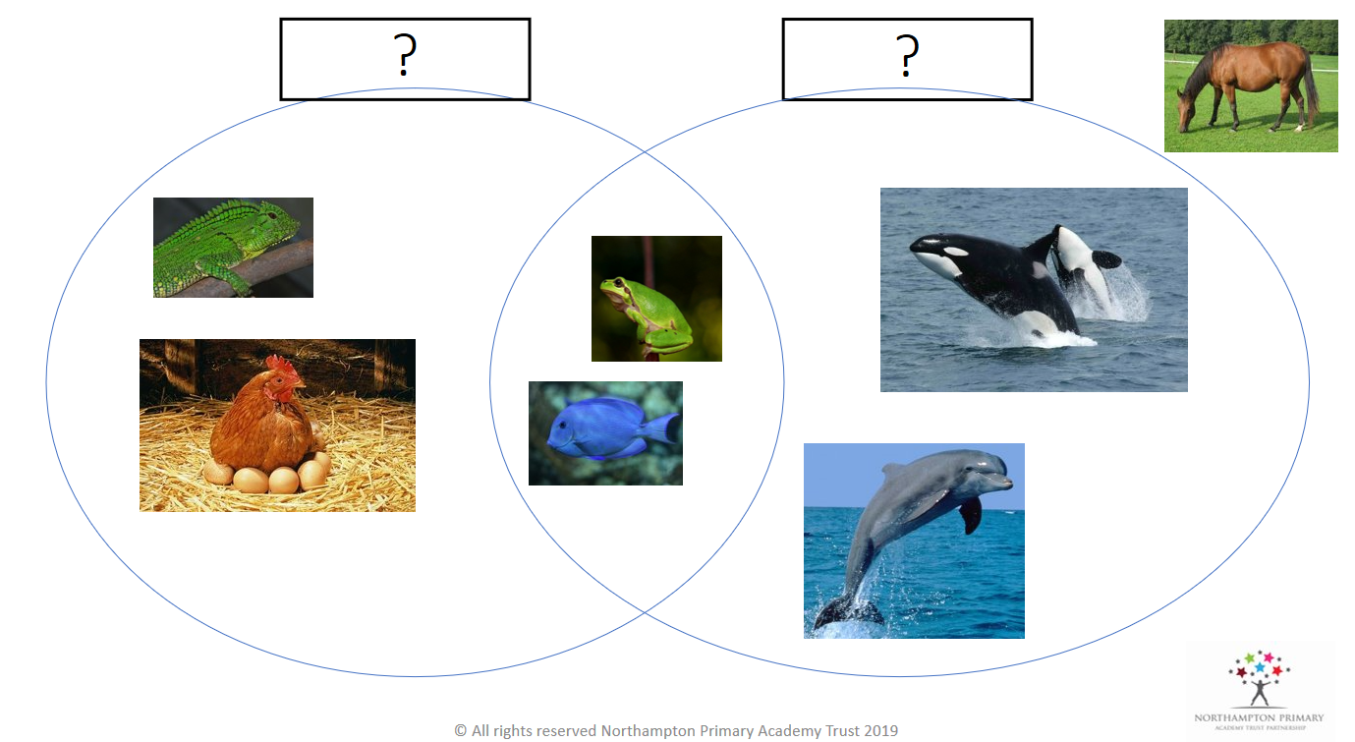
Can you come up with titles to label the Venn diagrams? What do the animals in each circle have in common?

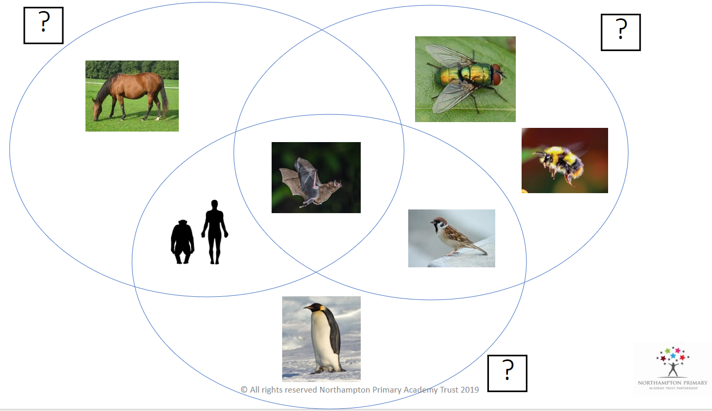

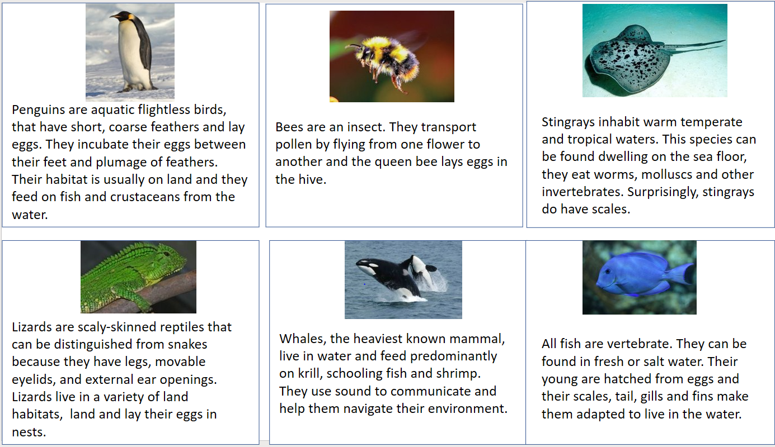

Can you create a Venn diagram using the animal pictures above? How many circles will you need? How will you label them?

Key vocabulary:
