Year 4 RE week 4

Last week you investigated Pentecost.
Can you find the symbols associated with Pentecost/the Holy Spirit?
Draw each symbol and explain what it represents.
Can you answer the following questions:

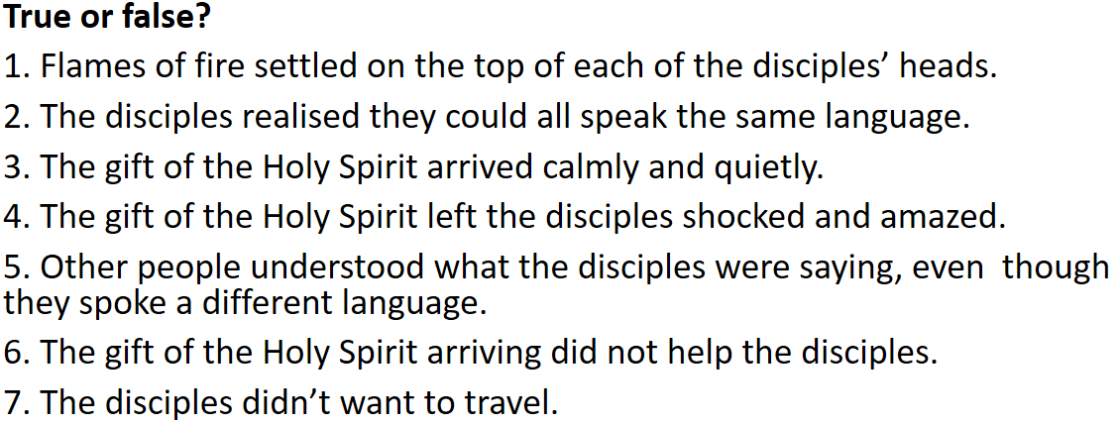

Have a go at writing a poem about one of the symbols.

