Solutions for the assessment KS2 NC Test - Paper 3 Reasoning
1)  20 , 12  15 , 17 | 2) missing numbers are -3 and 3
3) 5 | 4) 13
5) Amount = 840 ml | 6) 0.8, 0.812, 0.86, 0.873, 0.89
7) sixty-four thousand, one hundred and fifty-eight

8) 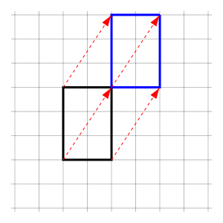

9) 1.87 kg | 10) 64 $÷$ 8 = 8p  45 $÷$ 5 = 9p  8 is less than 9, so shop A is cheaper
11)  17 1 18  13 12 11  6 23 7 | 12) 8.531
13) $\frac{5}{12}<\frac{4}{9}$ | 14) missing numbers are 0.35 and 0.39
15) 4, 1, no  4, 0, no  4, 0, no | 16) 26
17) 40 % | 18) 20 cups of flour
19) Perimeter = 36 cm, Area = 53 $cm^{2}$, Difference = 17 | 20) $(16,16)$

