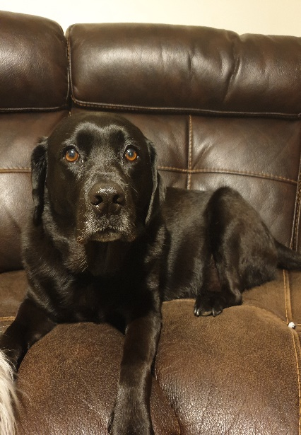
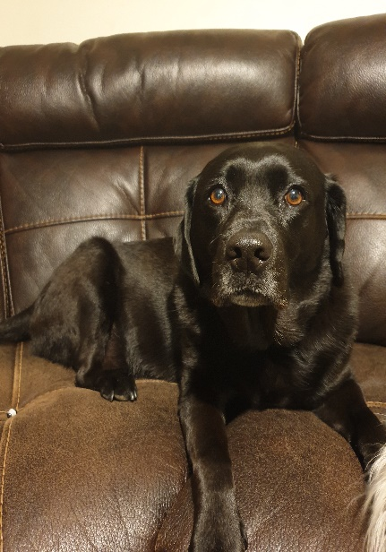
BELLA’S READING CHALLENGE
Week 2 – 27/04/2020 – 01/05/2020

Colour the paw prints as you go!

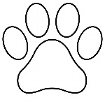 | Read to your favourite toy
 | Read a mystery
 | Read a non-fiction book (not a story book)
 | Read on the toilet (do not drop your book!)
 | Read a packet of ingredients from the food cupboard
 | Read before a meal
 | Read a newspaper or a magazine
Read about a place you would like to visit
(could be the moon!)

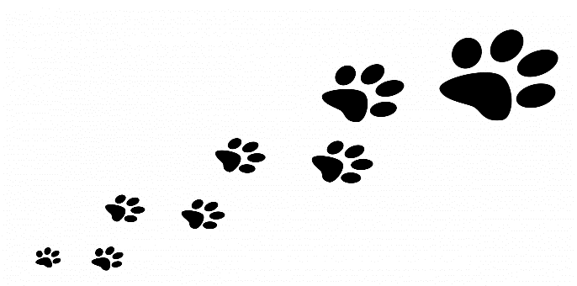
You can read on someone’s computer, tablet, phone or a book in your ho

